Digit: A low-cost, open-source, and universal HID for ALS care
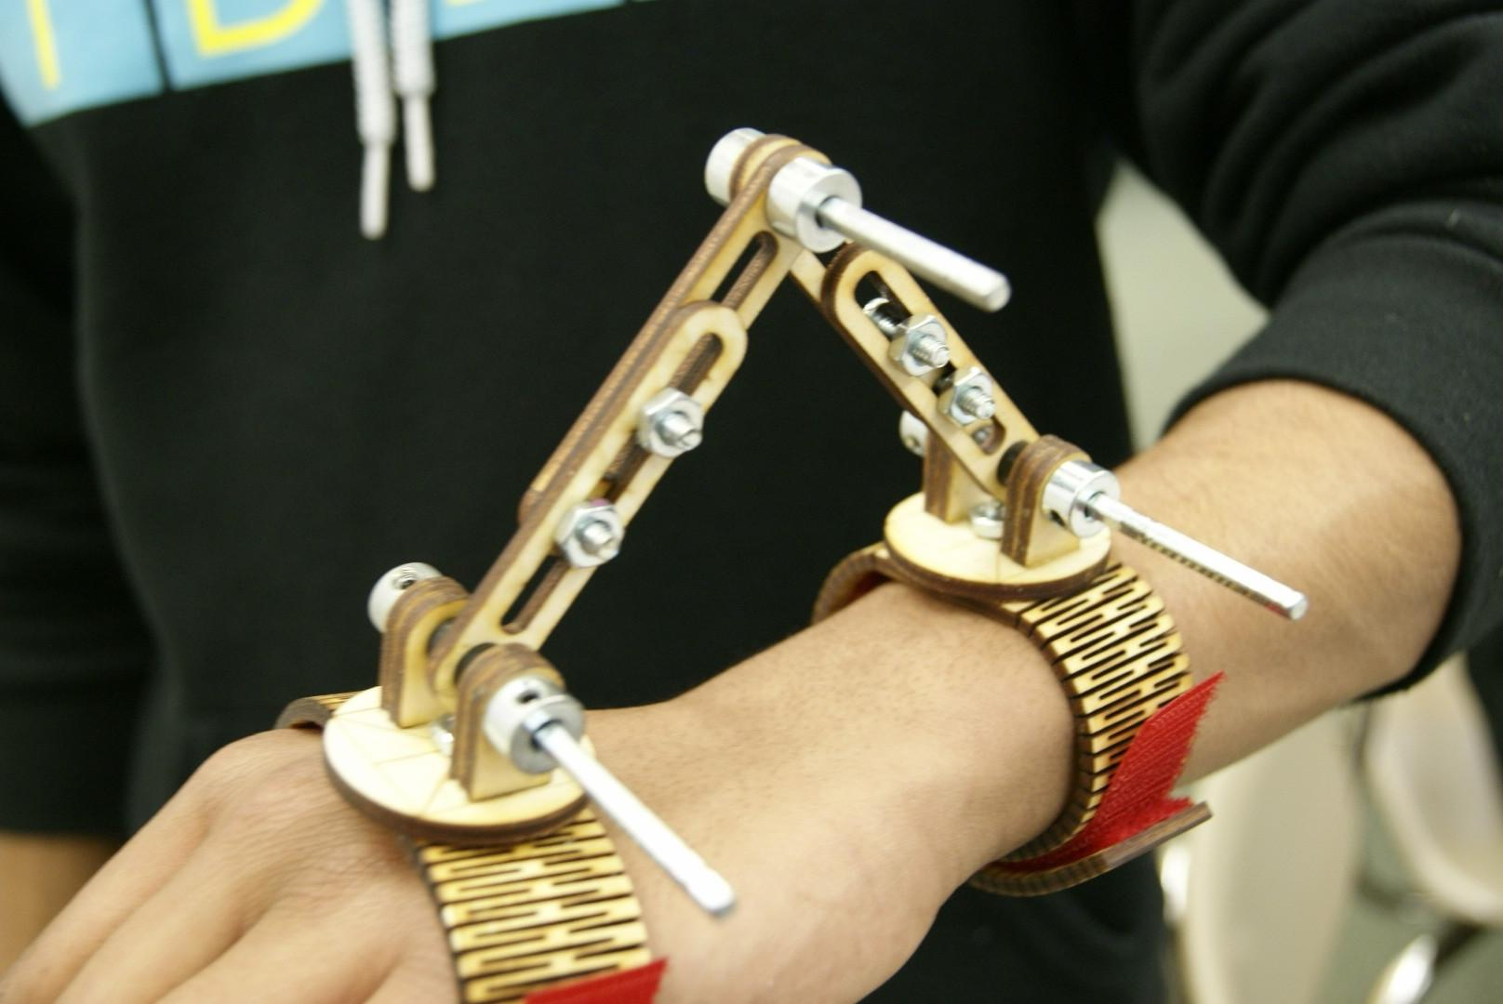

Anand Sekar
IB Design & Technology
Inglemoor High School
Kenmore, WA, USA
3/27/16

Contents
1. Analysis of Design Opportunity 2
Design Opportunity 2
Market & User Research 4
Design Brief 9
Design Specifications 10
Marketing Specifications 10
2. Conceptual Design 11
Development of Ideas 11
Concept Modeling 16
Development of a Solution 17
3. Detailed Design 19
Materials and Components 19
Manufacturing Techniques 22
Design Proposal 22
Manufacturing Plan 23
4. Testing and Evaluation 32
Evaluation Against Design Specifications 32
Evaluation Against Marketing Specifications 33
Improvements/ Next Steps 34

- Analysis of Design Opportunity
  - Design Opportunity
Outside of school, I engage myself in embedded systems projects; I am interested in computer engineering at the moment. Recently, someone close to me was diagnosed with ALS; it inspired me to look into the future and try to solve any problems that would arise.
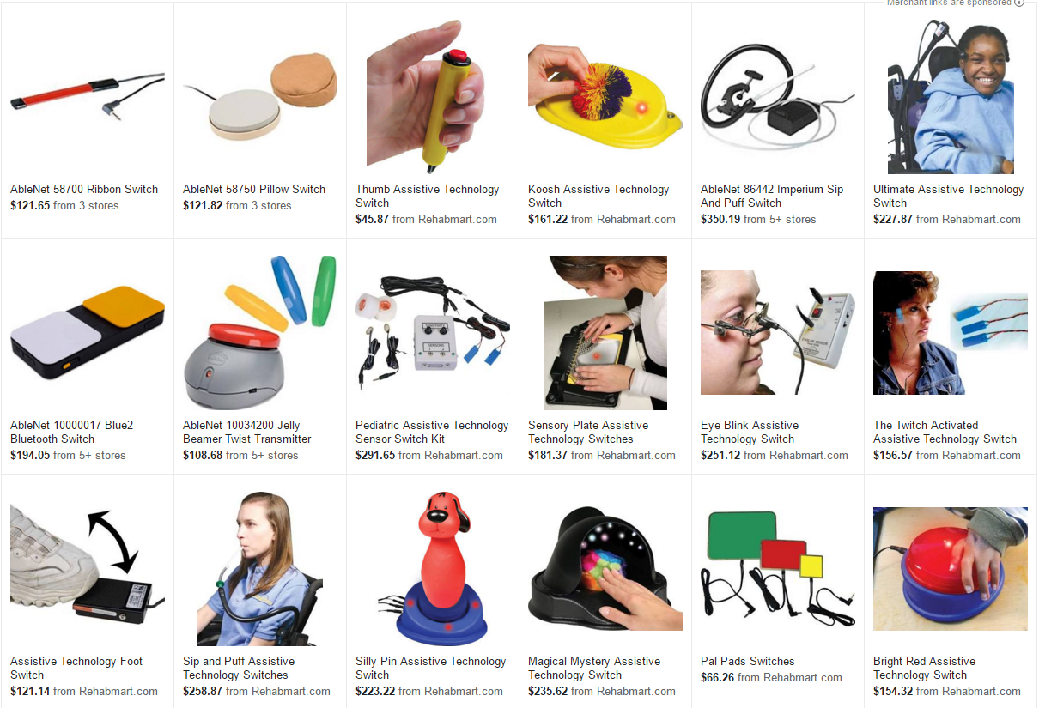
ALS is a progressive neurodegenerative disease in which patients experience degradation in the strength and control of voluntary muscles, until complete paralysis. Common early symptoms include muscle stiffness and twitching, gradually progressing to difficulty in speaking and swallowing, and eventually respiration. For more than 90 % of cases, the cause is unknown. There is no known cure, and the only existing treatment extends life expectancy by a mere two months. Most treatment is in the form of symptom management based on assistive technologies. Most assistive technologies involve regaining the ability for normal life, centered on concepts such as robotic arms and wheelchairs. The cost of implementation of these technologies is generally in the order of magnitude of tens of thousands of dollars. Even simple buttons designed for wheelchair input are hundreds of dollars. A simple search on Google Shopping shows the average price for devices as simple as buttons.
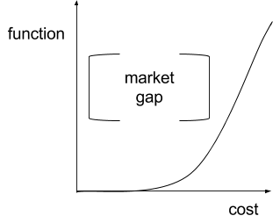
The high cost of modern assistive technologies is due largely to the difficulty of necessary customization to a specific user. For example, wheelchair control mechanisms need to be adapted to each individual depending on their unique progression, driving prices up by orders of magnitude .This creates a market gap: there are no assistive technology human interfa ce devices that are inexpensive and functional enough for ALS patients. Because the progression of ALS is highly variable, it affects patients in different regions at different times and thus requires a variable method of symptom management.

  - Market & User Research
In the healthcare sector, we have five parties: the patient, the caregiver, the assistive technology providers (ATP) & care coordinators, the insurance & financial assistance providers, and the ALS researchers. In my research, I explored many of these different perspectives.
Patient & Caregiver Perspective
I first began by looking at the perspective of the patient diagnosed with ALS and the caregiver who will assist the patient in daily living. In the patient-caregiver dynamic, there were two interactions that were significant. I first began by dividing the problem into two categories of implementation: tasks and metrics. Tasks were “pragmatic” - creating tools to execute physical tasks that would otherwise be executed by the caregiver or other assistive technologies. An example of a task would be simply taking a shower or eating breakfast. Metrics were “theoretic” - creating monitoring methods to better inform the caregiver. An example of a metric would be blood-glucose levels. I first began to focus on a wheelchair, since this was the most ubiquitous form of assistive technology. This was a mistake take care of later in the design process.
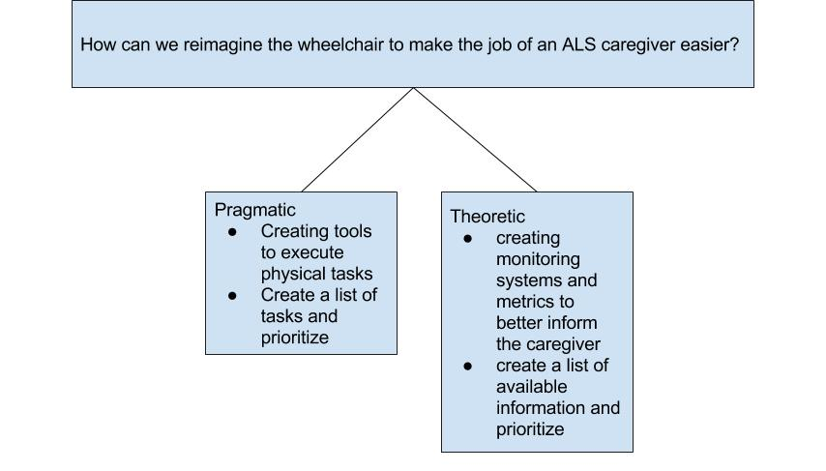
Trying to find the most prominent problems with assistive technologies, focusing on ALS patients & caregivers, was a path with many routes. I spent months researching different issues, using all the resources I had available. I realized that I should simply focus on the pragmatic side of things. My first plan of action was to create a list of different physical tasks that people accomplish frequently - something that ALS patients usually have difficulty doing. Meanwhile, I categorized these tasks and wrote down peripheral thoughts that came to mind.
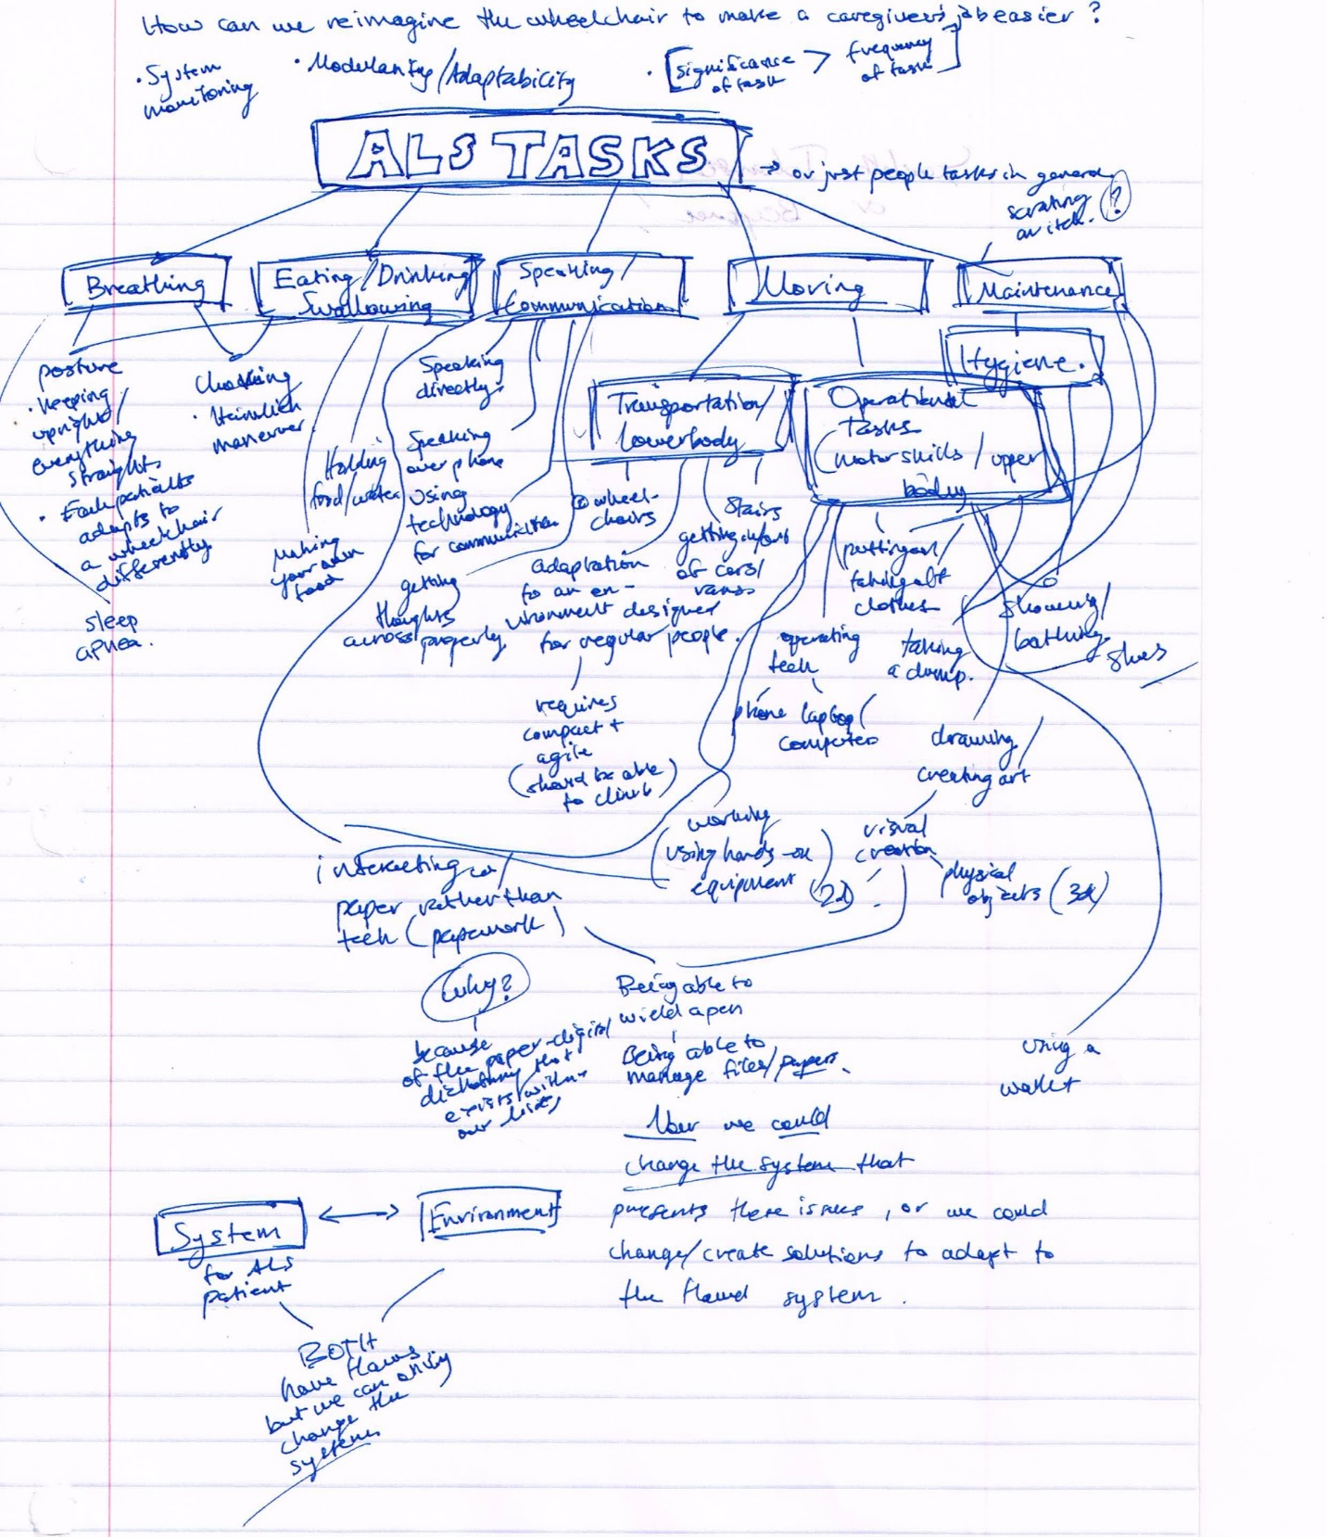
I decided I wanted to pursue further problems in the scope of a wheelchair, so I decided to borrow a wheelchair and perform an empathetic case study and see what new tasks would arise. On February 4th, I spent the entire school day in a regular wheelchair. I discovered several problems:
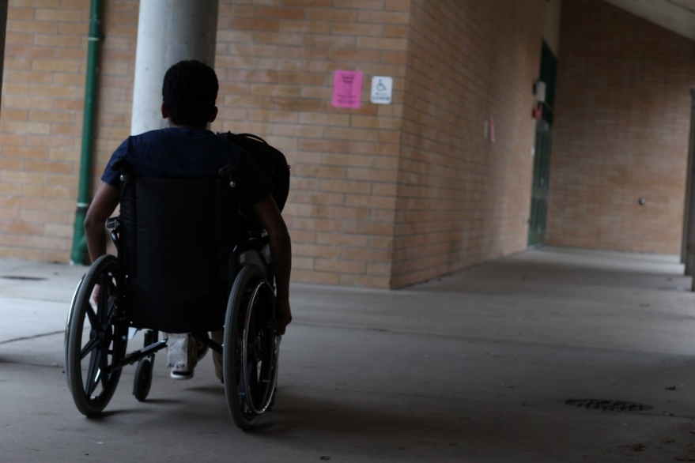
- Going up & down hills (power & braking)
- Being shorter than everyone else
- Opening doors
- Carrying items such as my backpack
- Getting around without another’s assistance
- Becoming an obstruction to others
- Maneuvering around tight classrooms & workspaces
Although many new insights were revealed to me, upon further research, each and every one of these issues were either solved by existing power-chairs or in development. After spending so much time trying to find issues within the scope of the patient & caregiver, I decided to expand my perspectives.
The Assistive Technology Provider Perspective
My first contact was the Care Services Provider of the ALS Association Evergreen Chapter: Oliver Ross. Oliver knew my interest in assistive technology beforehand, so when I told him about my project, he was happy to help. He referred me to my two main contacts: Nathaniel Swenson and Jackie Gaddis.
Nathaniel Swenson is an assistive technology provider working at Dependable Medical Equipment. He specializes in designing custom seating for complex rehab equipment, working as part of a rehab team with patients and their therapists to develop custom wheelchairs that optimize comfort and independent mobility. Nathan gave me a tour of the medical equipment warehouse, which mainly focused on the supply, maintenance, and adaptation of wheelchairs and other assistive technologies. He gave me several design opportunities that I am pursuing separately. Based on my tour of the DME warehouse, I realized the extreme cost and effort required to customize input devices (such as hand joysticks, head switches, sip & puff, and foot joysticks) for each patient.
Assistive Technology Coordinator Perspective
Then I emailed my other contact. Jackie Gaddis is the assistive technology coordinator at the ALSA Evergreen Chapter. She is a versatile individual providing comprehensive assistive technology services as it relates to augmentative and alternative communication and access to other technology. She works with the Chapter's Care Services staff to provide technological support to families living with ALS throughout the service area: Washington, Idaho, Alaska and Montana. I asked for a “wish list” of things that would make her life easier. The list included a couple things:

“cost-effective wearable movement-activated switches - as opposed to buttons; something where someone can move, say their neck a certain way/timeframe and can call for assistance or select options on a computer. Due to the muscle functional loss, it can be difficult to target a "button" when positioned next to the person, as well as muscle weakness becoming an issue sometimes when targeting and pressing hard enough. I saw on wireshark a guy that made gloves where if fingers are pressed together music can be turned on/off, and other options (like for people skiing and such),”

“A wearable Finger Mouse/foot mouse PEN that works on all surfaces or NO surface, so spelled letters are read out loud. This to act as a speech Generating Device but small and more portable.”
Combining the perspectives
I was invited to the Bailey Boushay House, an assisted living facility, during an assistive technology-focused ALS support group meeting. Both Jacqueline Gaddis and Nathaniel Swenson were there, along with others who had or were affected by ALS.
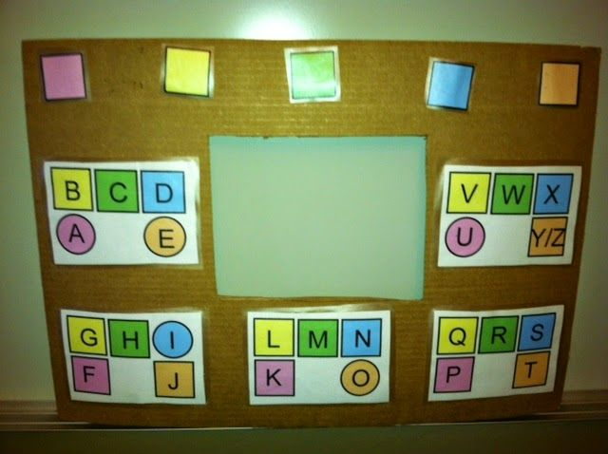
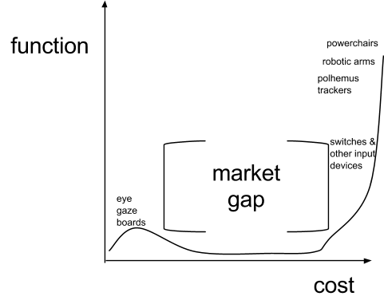
Here, all perspectives relevant to my project were present: the patients, the caregivers, the assistive technology providers, and the assistive technology coordinators. Again, I was given many ideas that led to other, bigger projects. However, another thing that I noticed in particular is the inefficacy of current communication methods. A patient, with almost fully developed ALS, had such delay using the eye-tracking computer communication. I also learned of several low-cost assistive “technologies.” Eye gaze alphabet boards, for example, can be used to gather some input from the user by having a person hold up the board, look through the hole, and watch the direction of the patient’s gaze; the direction of their sight, with multiple steps, would eventually allow them to communicate letters and words. However, this requires the use of another human being and cannot interact with other technology. Now, I had to revise my view of the assistive technology market gap.

Key Findings
In summation, the main problems I noticed were:
- Inefficiency in the customization of assistive technologies
- Unreasonable pricing for simple assistive technologies
- The dependence of a patient on assistive technology providers.
Given all this information, I decided to change up a few things:
- I shouldn’t focus specifically on a wheelchair; it was distracting and unnecessary
- Rather than focusing on solely the patients and caregivers, I should also consider the other parties involved.
- The criteria of my solution, whatever it may be, must be excellent in three things: cost-efficacy, modularity, and adaptability.
Now my newer problem statement was “how can we improve assistive technology by making it more cost-effective, modular, and adaptable.” Although this was still vague, I realized that gathering input from a user to accomplish tasks was difficult. Eye-tracking devices were useful in optimal for using a computer after ALS has progressed almost fully, but a patient couldn’t do much else. There is a long period of time in which most patients are able to use whatever movement and functionality they have to control assistive technology. This input is taken in by devices that are customized for a specific patient - resulting in high expenses and overall inefficiency. There was a market gap in the area of Human Interface Devices (HID) for the physically disabled. The solution required a balance between generality and specificity – to maximize the universality and efficacy of our solution with respect to cost. That would fulfill the market gap.
  - Design Brief
Goal:
Make a human interface device for the physically disabled - specifically ALS patients - that is adaptable, modular, low-cost, and eventually open-source. Should be able to at least fit on the head, hand, and foot of nearly any person. Must be complete within two months.
Target Market:
- ALS patients and those affected by other neurodegenerative diseases in need of using assistive technology to accomplish tasks
  - Submarket: ALS assistive technology providers who are tired of customizing human interface devices to a patient.
Criterion:
- Cost efficiency
- Modularity
- Adaptability
- Universality
- Open-source/ development platform.
  - Design Specifications
- Cost efficiency: due to the market gap in assistive technology human interface devices, there are no low-cost options that provide higher, computer-oriented functionality.
  - The HID must be reasonably under 10 USD
- Functionality
  - The HID must be able to control a mouse on a computer
- Universality
  - Modularity
    - The HID must be modular so that the user, according to his/ her budget, can choose just the parts they require.
  - Adaptability
    - The HID must be able to be used on nearly any part of the body, but given the time constraints, within two months, it should only be required to fit on the head, hand, and the foot.
  - Ergonomics
    - The HID must be able to fit on any human with few exceptions. Within the two months, the device must be able to fit on humans who are not atrophied to the extent where a limb cannot be used or has become malformed.
- Further Development
  - Open Source Development Platform
    - The HID should be simple enough so that it can serve as a platform for further development and applications that can be taken by the maker community. This would be executed preferably through an online file base.
  - Marketing Specifications
- Target Market
  - Involves the healthcare sector
    - Within the healthcare sector, the HID must focus on the assistive technology market
- Target Audience
  - Main Audience: ALS patients (direct)
  - Side Audiences:
    - ALS caregivers: it will be easier for the caregiver if they are able to receive further input, control, and independence from the patient
    - ALS Assistive Technology Providers: ATPs won’t have to customize expensive technologies for their patients.
    - ALS Assistive Technology Coordinators: The coordinators will have far less financial obstacles
- Market Research & Analysis
  - According to a report from BBC Research, the global market for assistive technologies is projected to reach 40.9 billion USD in 2016.
  - There is a market gap for cheap assistive technologies that have computer capabilities
- User Need
  - The ALS patient needs a cheap human interface device that they would be able to use – to whatever functionality they require – without expensive customization from an assistive technology provider
- Current Market Solutions & Competition
  - A six-axis head mouse would be able to achieve what is necessary for this design functionally, however, prices are in the hundreds of dollars.
  - Basic switches are low-functionality: they’re just buttons. However, they still are over-expensive in the range of 50 – 100 USD.
  - There is no market solution for assistive technology that is under 10 USD AND can control a computer.
- Conceptual Design
  - Development of Ideas
The Nose Morse Code
I was sitting on the couch, thinking of the communication methods from the ALS support group. Brainstorming of different ways of unique communication, I came across a method I had developed a long time ago with my brother: Nose Morse code. Basically, my brother and I could stare at each other and easily communicate without others really noticing - by flaring our nostrils at timed intervals with respect to Morse code. I tried to abstract this concept as much as possible - breaking down this complex movement of flaring nostrils: the measurement of the distance between two points over time. One point in space was on my left nostril, and the other point was on my right nostril. I took this concept of measuring the distance between two points analogously to the rest of my body. For example, looking at my right index finger, I imagined a point on the tip of my finger and a point on my knuckle – with reference to a 3D axis.
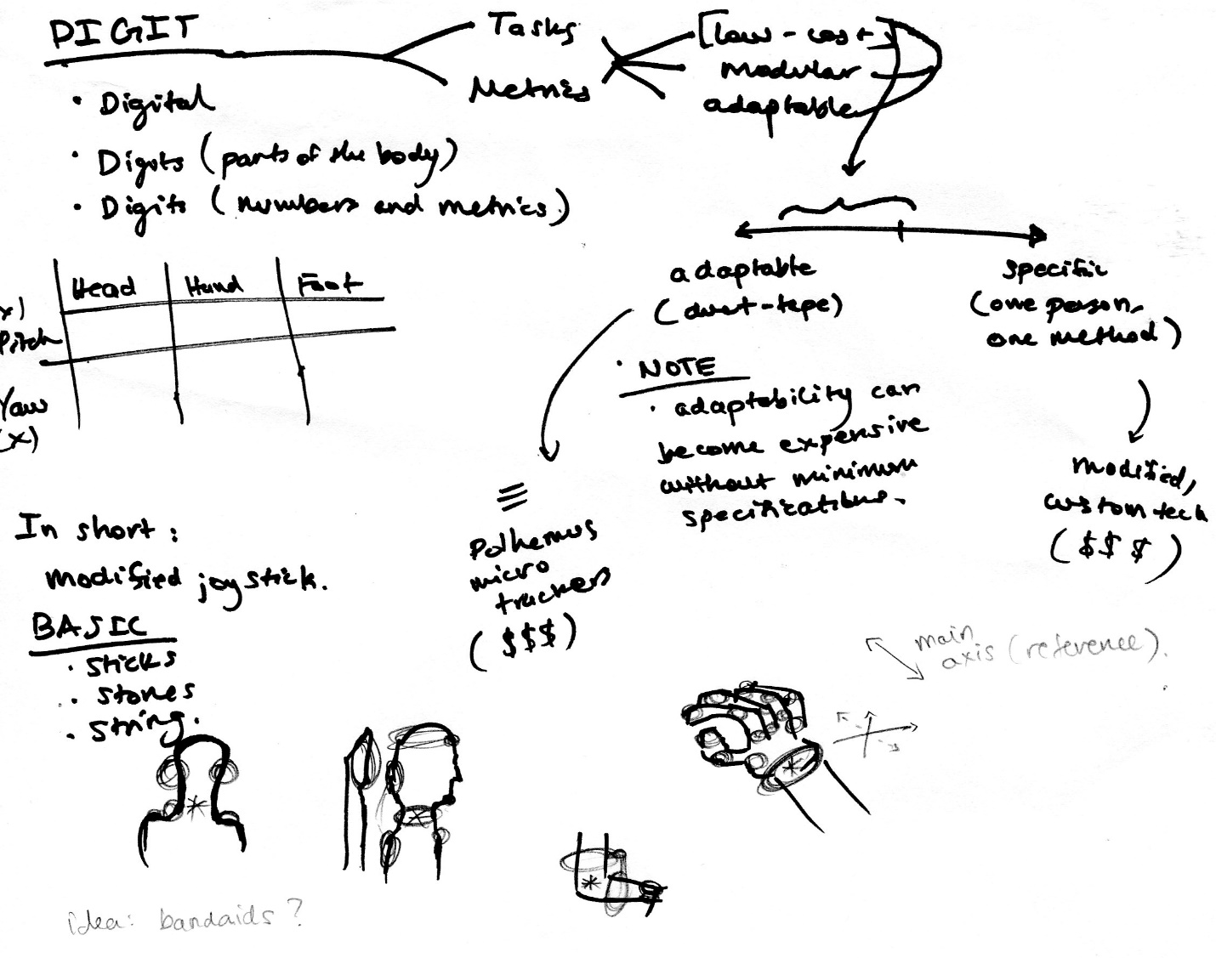

If I were to simply know the distance between those two points, I would be able to understand and model the movement of my finger. Moreover, there were other properties that could be measured - such as angle. “Knowing” the movement of the body using simple measurements could act as input for human interface devices. Keyboards, mice, eye-tracking cameras and speech-recognition all measure different outputs of the body. Given the presently unpredictable and specific muscular deterioration of each patient, it’s difficult to develop a general device that could adapt to all these movements.
Categorizing Movements.
I tried to come up with as many creative ways of measuring inputs from the body.
Movements | Head | Hand | Foot
Pitch | Measure vertical distance between stationary point (like chest) and anywhere on the head  Measure angle of head w/ respect to ground  Measure flex/ bend of head w/ respect to back | Grip muscles flex  Distance of a point on the end of the hand to anywhere  Measuring the curve of the wrist | Contraction of calf/ shin muscles
Yaw | Measuring the distances between two points across the line of symmetry and a stationary point (such as on the chest)  Angle of a line between a point on the head and a stationary point.  Measure velocity (to measure direction)  W/ direction, measure distance between one point on head and a stationary point | Distance between a point on the side of the hand and the forearm/ elbow/ stationary point such as the chest  Angle of side of hand w/ forearm | Distance of point of end of foot w/  Measuring the movement of the kneecap]  Distance of one point w/ stationary point and direction of movement
Roll | Distance between the ear and the shoulder (or another stationary point)  Measure angle of head w/ respect to ground  Angle of glasses w/ respect to ground  Difference of height between earrings | Measure the angle of the plane of the palm with the plane of the ground  Compare vertical height of right side w/ that of the left side to the ground/ wheelchair arm. | --
Planar Movement | -- | Distance of hand to stationary point  Distance and angle of a point in center of hand relative to a point on the wheelchair armrest | Distance and angle of one point in the foot w/ the ground/ wheelchair  Distance of one foot w/ the other

To find the cheapest solution, I needed to find the simplest solution. To find the simplest solution, I need to simplify the movements of the body, specifically in three parts of the body: the head, hand, and the foot. I categorized movements into: pitch, roll, yaw, horizontal and vertical planar movement. I measured my own body to get rough ergonomic measurements with range, preferred values, precision, and comfortability.
Case studies: [“] | Head | Hand | Foot
Pitch |  | (convenient)
Range | (-40°, 30°) [3.76, 2.85] | (-30°, 30°) [3] | (-20°, 20°) [3]
Preferred values | -10°, 10° [1] | -10°, 10° [1] | -5°, 10° [.8, 1.5]
Precision ± | 5° | 5° | 2.5°
Roll
Range | (-40°, 40°) | if flat: (0°, 90°)  if vertical: (45°, 45°) | (0°, 5°)
Preferred values
Precision ±
Yaw |  | (comfortable)
Range | (-45°, 45°) [4.2] | (-30°, 30°) [3] | (-30°, 45°) [4.7, 7]
Preferred values | -10°, 10° [1] | -15°, 15° [1.6] | -5°, 5° [.44]
Precision ± | 5° | 5° | 2.5°
Horizontal planar movement
Range | 1” forward/ backward  0” left/ right | 1” backward, 3” forward  3” side-to-side | 4” forward, 3” back  5” out, 3” in (sideways)
Preferred values
Precision ±
Vertical planar movement
Range | 0 | 5” up/ down | 1” - 2"up/ down
Preferred values
Precision ±

Once I realized that the two best movements were pitch (up & down) and yaw (side to side), I began thinking of ways to measure those. I defined the “best” movements as those with the biggest range, comfortability, and lowest required precision.
After considering multiple methods of measurement, I decided to implement a simple mechanical solution. As opposed to Polhemus trackers (six degree of freedom microsensors which cost thousands of dollars) a mechanical implementation is cheaper by several orders of magnitude. These won’t fit the design specifications.
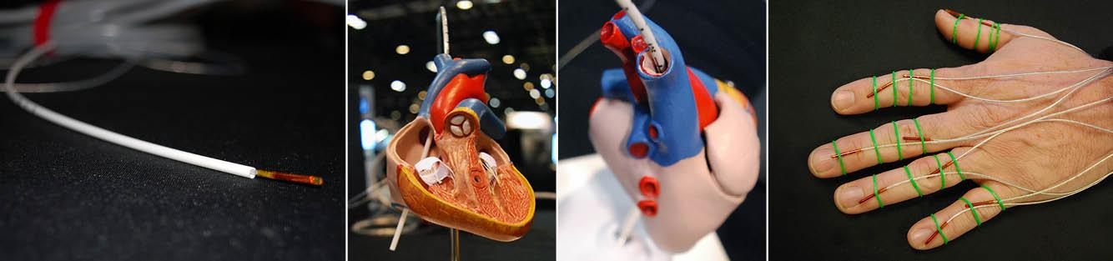
Another solution would involve Inertial Measurement Units (IMUs). In the short time span, I don’t believe there was a way I could figure out how to implement them. More importantly, they are certainly over $10. IMUs would certainly be a future, modular expansion of the project, but they won’t fit the design specifications.
Continuing with the perspective of minimum necessary technology for required functionality, I decided that it would be best to stick with the simplest measurements and sensors required: angles and potentiometers. Potentiometers are simply variable resistors which can be used to measure angles. This is justified, because it’s simple (therefore cost-effective), and would be able to control a mouse cursor on a computer screen.
  - Concept Modeling
The First Model
I needed to model this concept quickly (in under an hour), so I used some LittleBits, some cardboard & ducktape, laser-cut “sticks,” various machine screws, and an ESD strap. This model involved a dimmer, i.e. a potentiometer, that was moved by the up-and-down movement of my arm. This potentiometer was connected directly to an LED that got brighter and dimmer depending on the position of my arm.
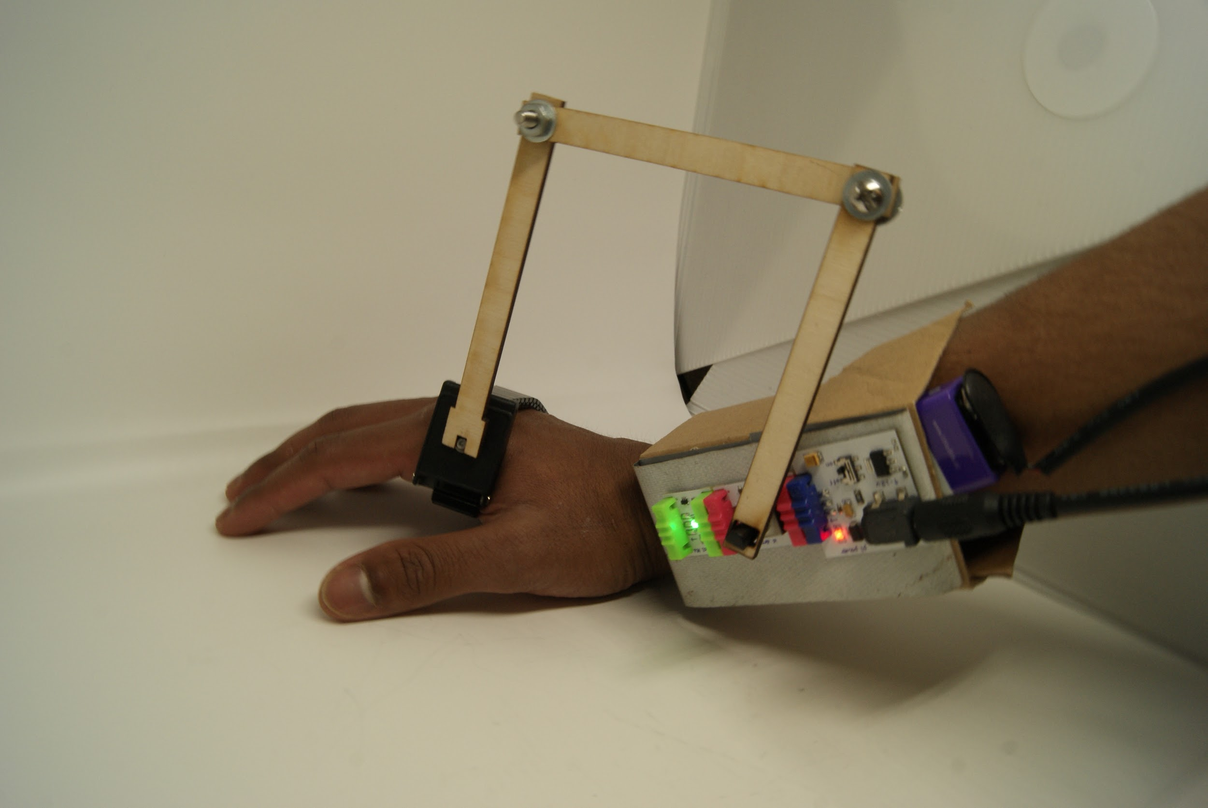
  - Development of a Solution
First Prototype/ Solution
There were two parts to the development of this project: mechanical and electrical. The mechanical part comprised of designing the hardware that would use potentiometers to “strap-on” to the body and measure its movement. The electrical part comprised of getting the analog data from the potentiometers into digital data that a computer could read as mouse data.
Since this was simply a prototype, I used whatever I had around me - which also happened to be low-cost. This involved a laser cutter, VEX robotics parts, scrap leather, and Cypress PSoC® 4 CY8CKIT-049 (Programmable System on Chip).
For the sake of low-cost, I laser-cut as many components as possible.
Digit is essentially a modified, adaptable joystick - it is based on the simplest available physical mechanisms.
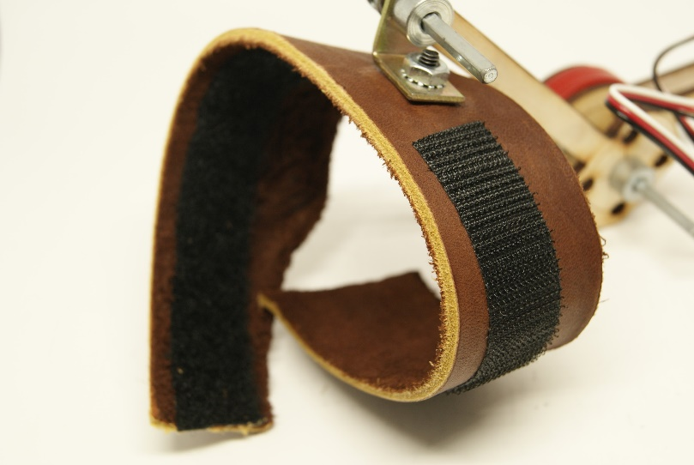
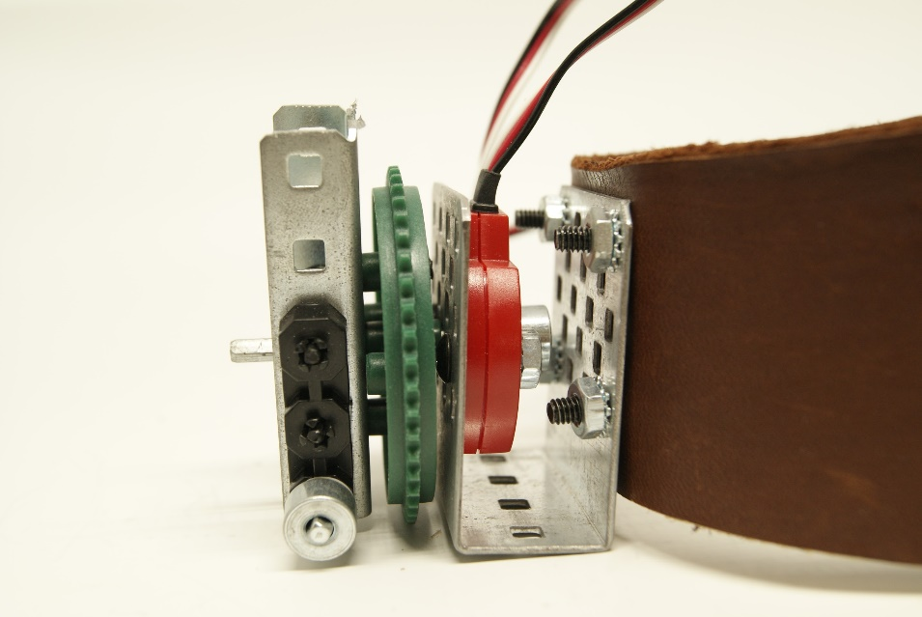
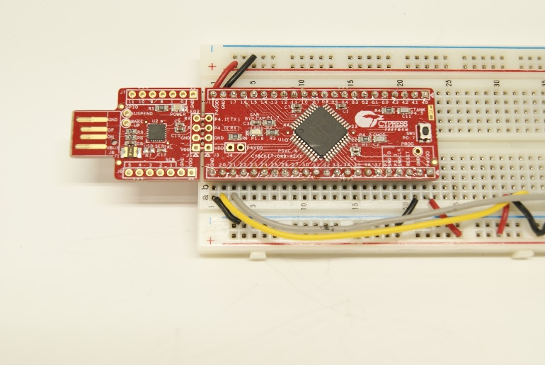
It extrapolates motion based on two potentiometers, measuring the angle of a joint with reference to the origin. The analog outputs of the potentiometers are interpreted by a PSoC microcontroller, and can from there be applied to nearly any assistive device.
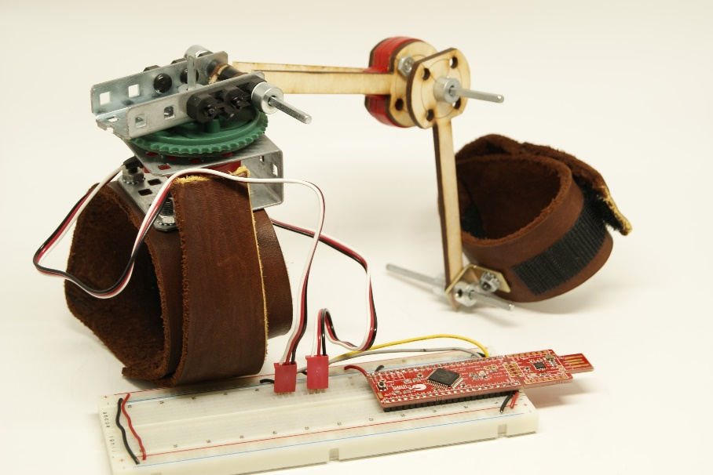
This prototype had some limitations:
- It was limited to only use by the hand. The overall design could be adapted and improved for the use of the head and the foot.
- The current prototype is a significant obstruction to certain activities, and is not ergonomically comfortable.
- The circuit with potentiometers is not robust: signal interference with the single analog-to-digital converter happens occasionally.
- The VEX potentiometers are imprecise and over $20. That does not meet the design specifications. There should be a better way to find through-hole potentiometers that are under $1.
- The PSoC 4 didn’t have the USB mouse capabilities (however, the PSoC 5 did)
- The design involves VEX prototyping parts, which are heavy, obstructive, and unnecessary. They were used simply because they were readily available. It would be much easier, in terms of manufacturing, to laser-cut those parts instead.
- The leather straps didn’t allow for compatibility with the head and the foot, and they had too much “give,” i.e. it wasn’t firm enough to record smaller movements.
- The square rods connected to the laser-cut “sticks” also had too much “give,” i.e. not moving with small movements. There was too much space between the rod and the hole although both were ⅛” (according to the laser-cut specs).
- Mechanical limitations
  - There were two types of holes:
    - Free: circular holes that allowed for free rotation
    - Fixed: square holes that gripped and moved with the square ⅛” rod
- I tried out different measurements with the laser cutter until I got a fixed square hole with virtually no “wiggle room.”
The first iteration of the “wearable joystick” had flaws that were solved in the second iteration. All the above flaws were fixed, and all the design specifications were met. It is a justified design.
- Detailed Design
  - Materials and Components
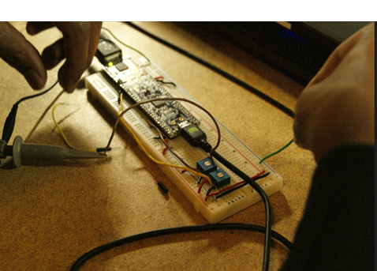 | 32-bit ARM® Cortex®-M3 PSoC® 5LP  “PSoC 5LP delivers unmatched parallel processing performance with a 24-bit Digital Filter Block (DFB), 24 UDBs and a high-performance DMA controller. PSoC 5LPs controller also helps you reduce BOM cost by integrating AFE, digital logic and user interface ICs with an ARM Cortex-M3 CPU in a one-chip solution.  PSoC 5LP also helps you simplify your system power architecture design by supporting the widest operating voltage range and multiple power domains in a single SoC.  Cypress’s PSoC Creator enables you to reduce development cost by using a single system development tool and ready to use PSoC Components, while accelerating your time-to-market” – Cypress Semiconductor.  The PSoC (Programmable System-on-Chip) was the best development kit to use because of its flexibility and specificity. Although the entire kit is $10, Digit only uses a fraction of a percent of the entire computer. In the future, the specific components can be produced into a low-cost chip with only the components necessary.  Moreover, this was a better solution than the PSoC 4 from the previous iteration because the PSoC has direct USB functionality – allowing the HID to act as any other USB mouse.
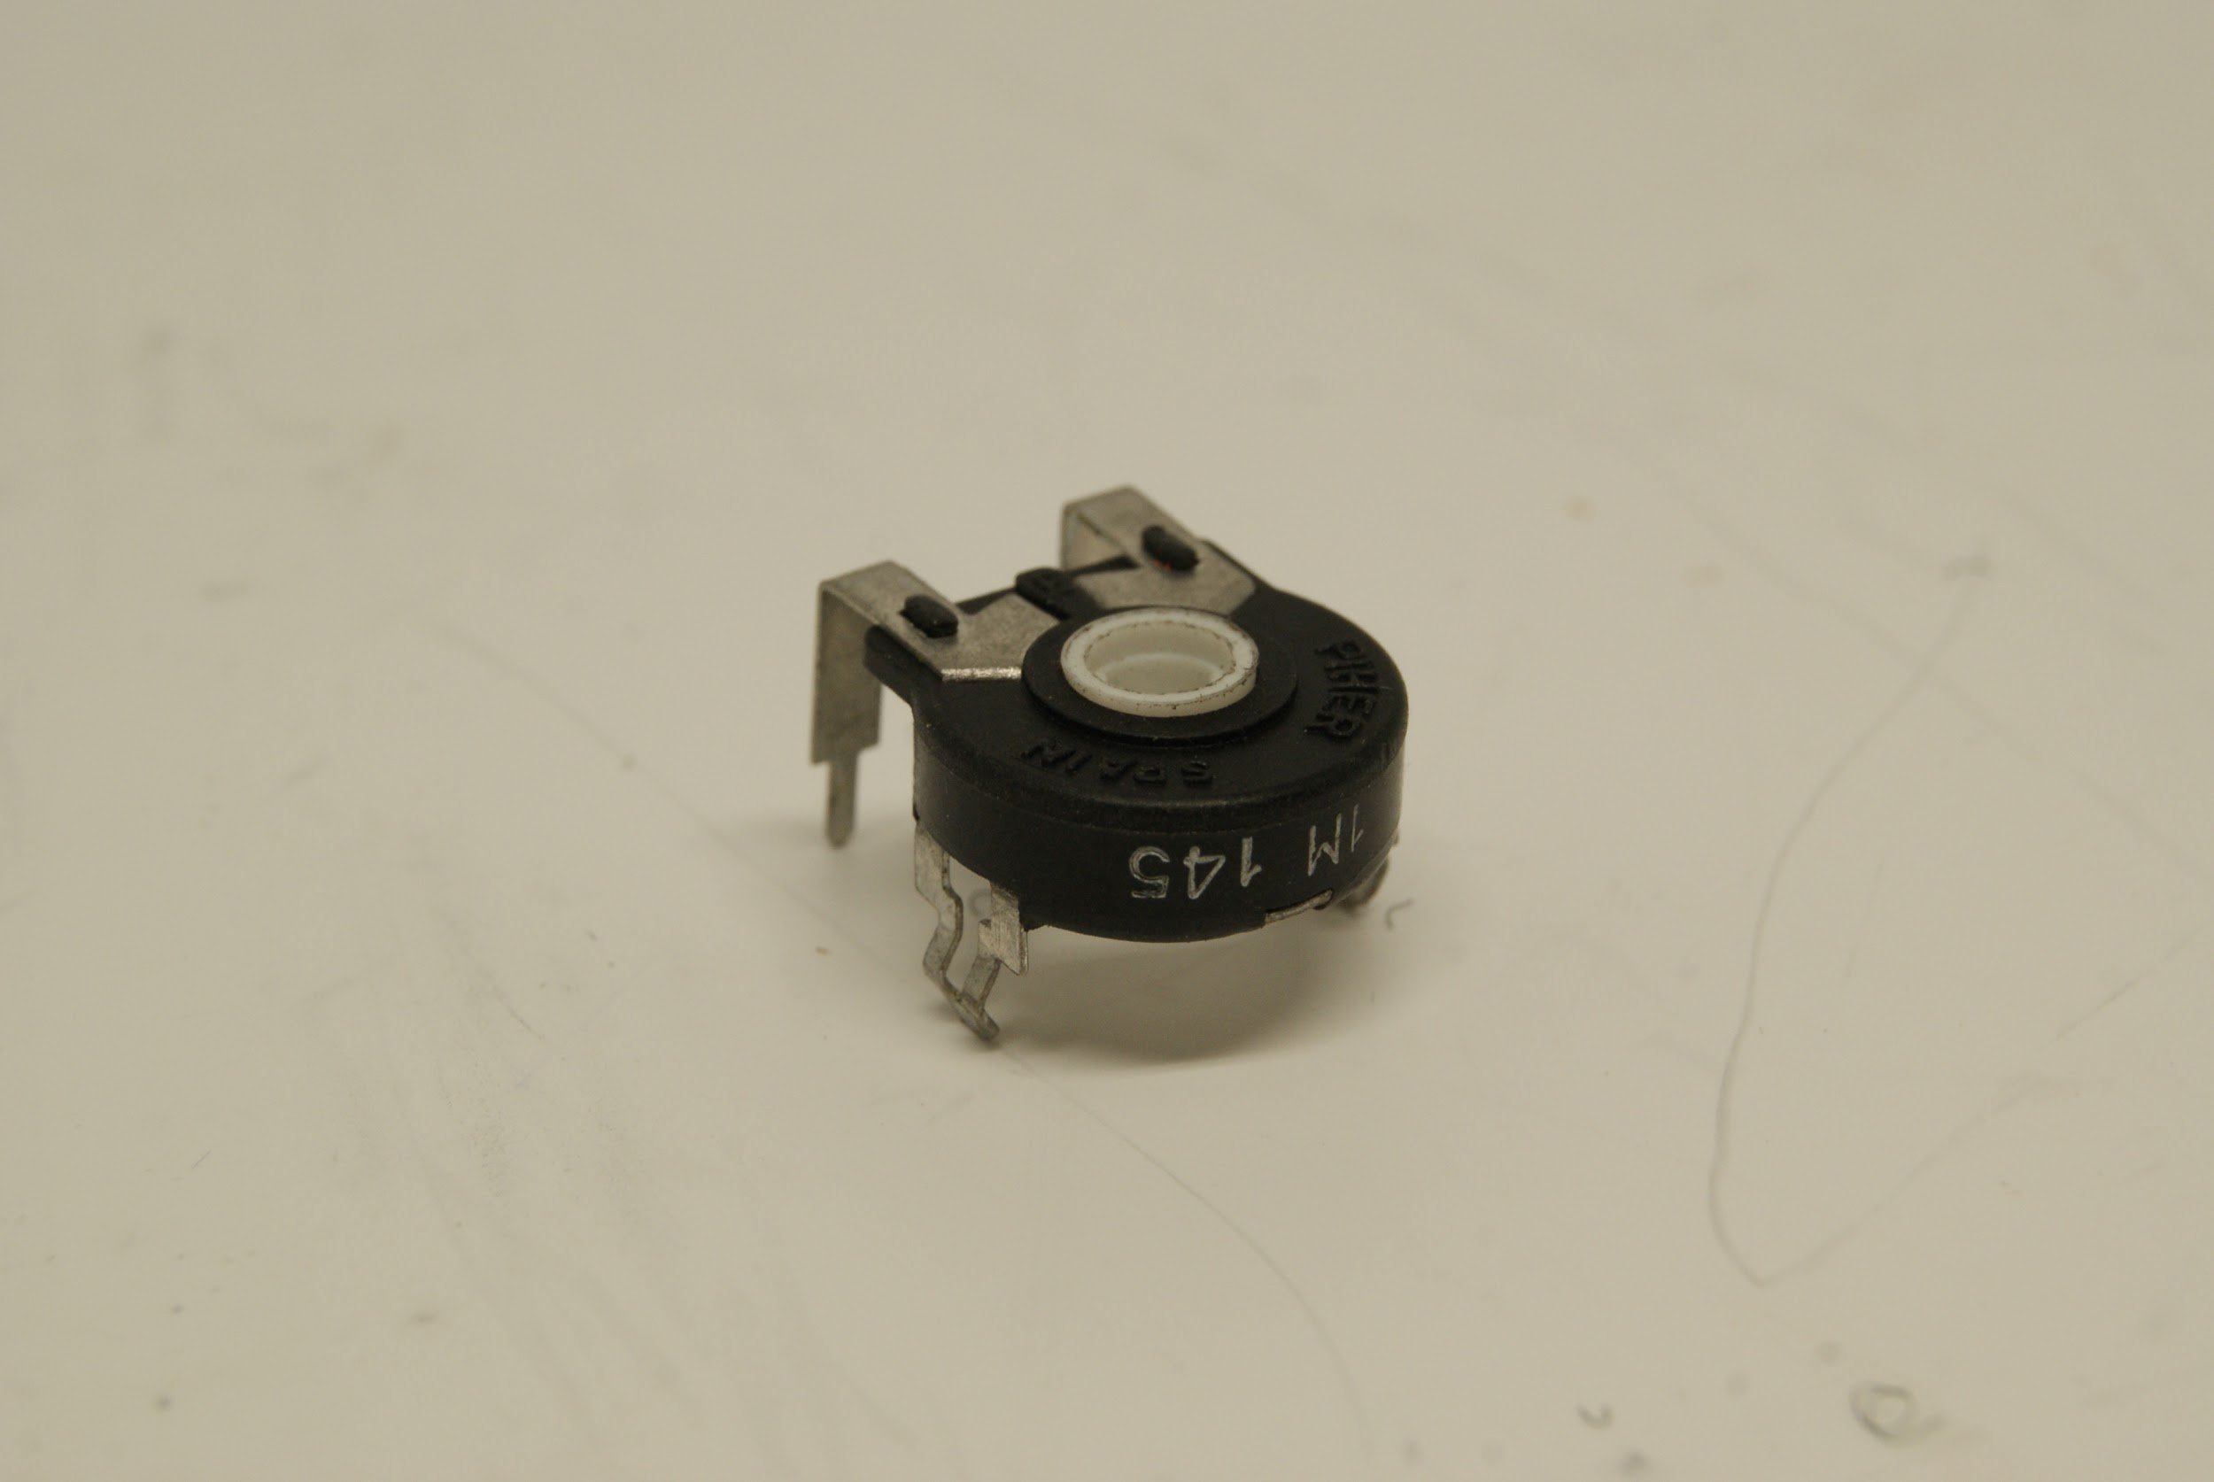 | Potentiometer  The PT15, a 15 mm carbon potentiometer, has the range and accuracy we need. It’s range is 265° ± 5° and its electrical rotation range/ accuracy is 240° ± 20°. Although ± 20° doesn’t fit the specifications in the table I developed, the values I mentioned were the angles of the body itself. The potentiometer measure the angle of the sticks connected to the body, which is designed to exaggerate the movement of the body. Therefore, the precision of ± 20° is good enough.
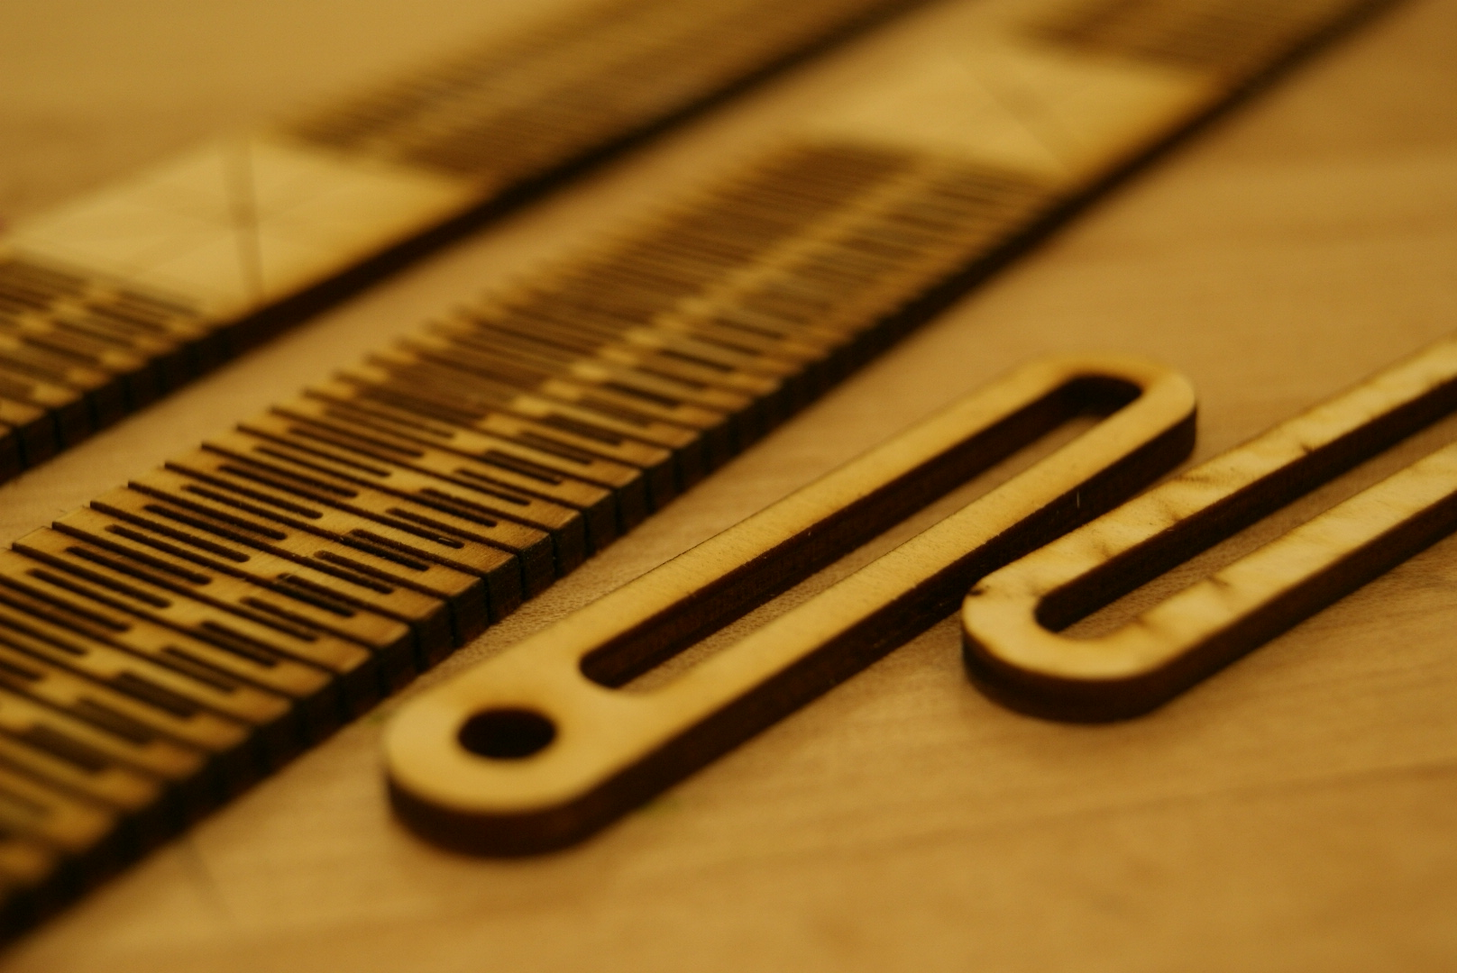 | 1/8” Birch Plywood  In general, this is a versatile and ubiquitous material for laser cutting. It’s relatively cheap ($3 for 24”x12”) and readily available. The organic nature of wood, however, can provide some imperfections. These imperfections are negligible for this design. As for the fixed square holes, they are sized so that as long as the laser cutter functions at its own precision, they’ll be the right size to fit the square rods. This wood is light and rigid. In the future, plastic may be a better option if more complex manufacturing is necessary. Also, the wood allows for the production of wooden straps, which are far better than leather: the wood straps are comfortable yet firm so movement is mechanically recorded with little error.
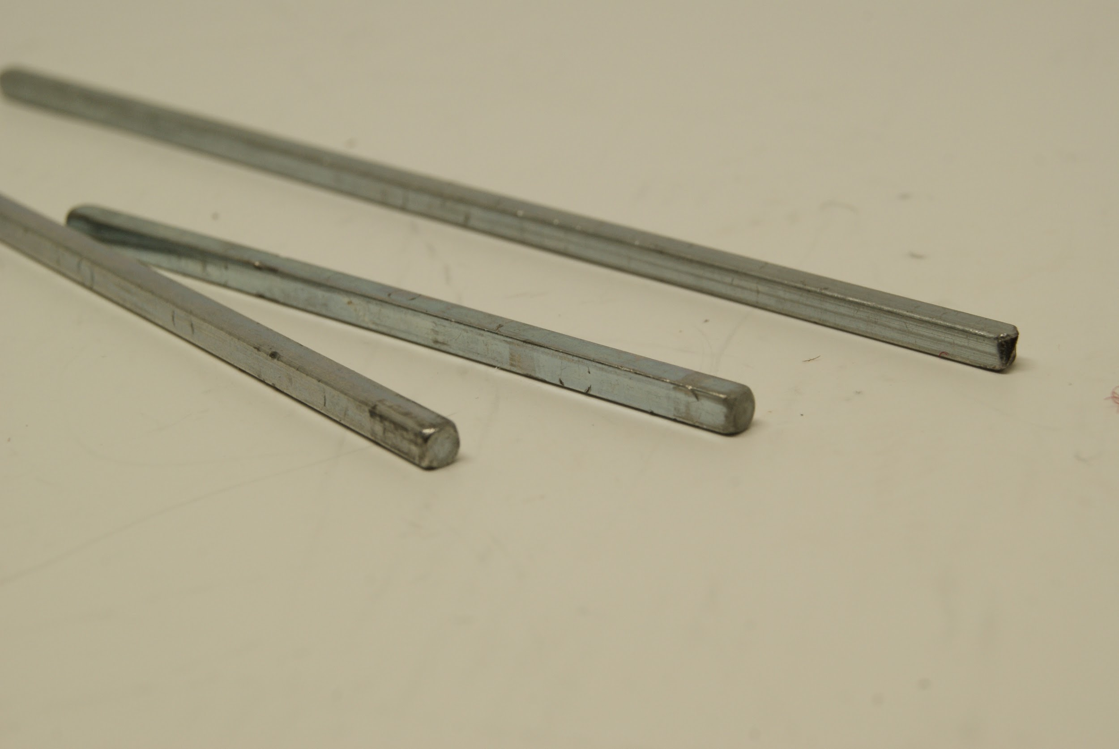 | 1/8” Square Shafts  These rods are made of 1018 Steel. This material is definitely rigid and strong enough for our purposes.
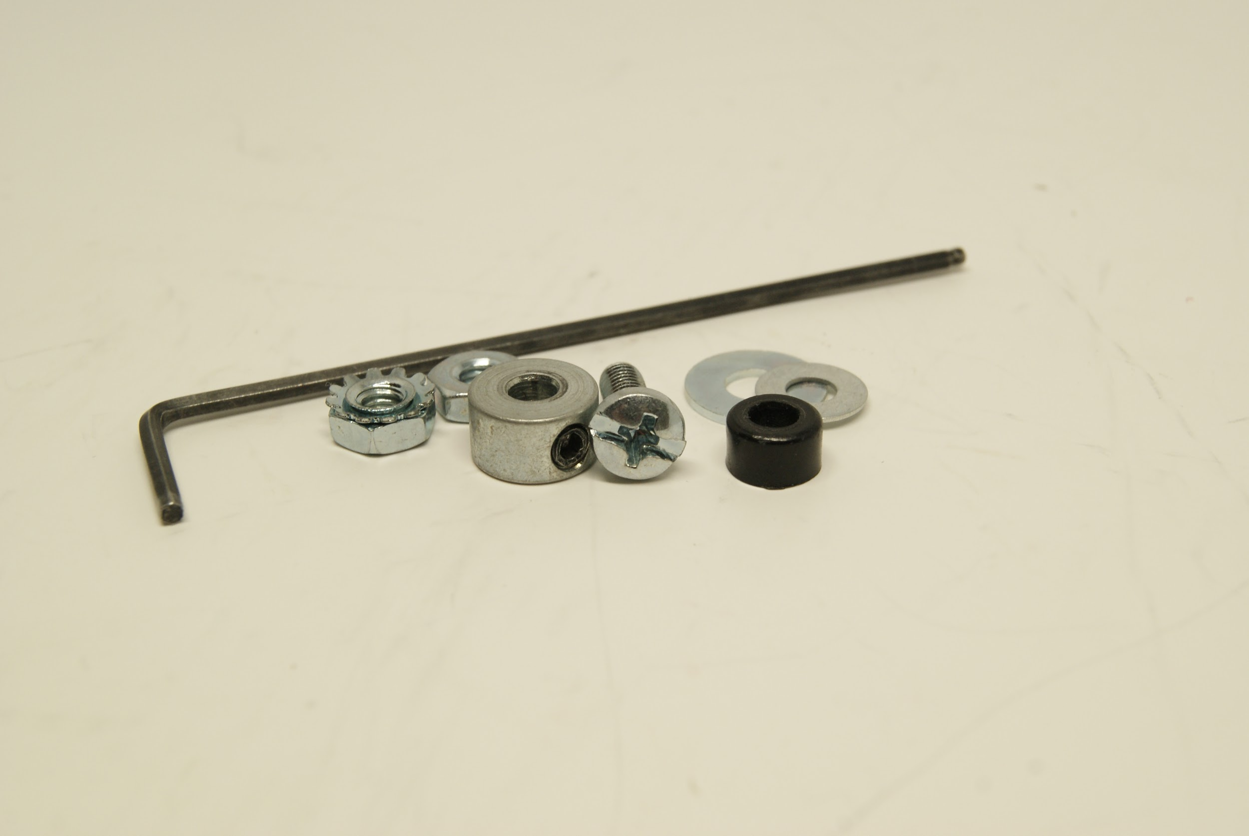 | Assorted Machine Screws, Nuts, Collars, Washers, and Spacers  Readily available common machine screws (1/8”); respective nuts (grip, regular); collars, washers, and spacers were the cheapest option. Although they are not ergonomic for the user, these parts can easily be replaced with more ergonomically comfortable options, e.g. wingnuts.
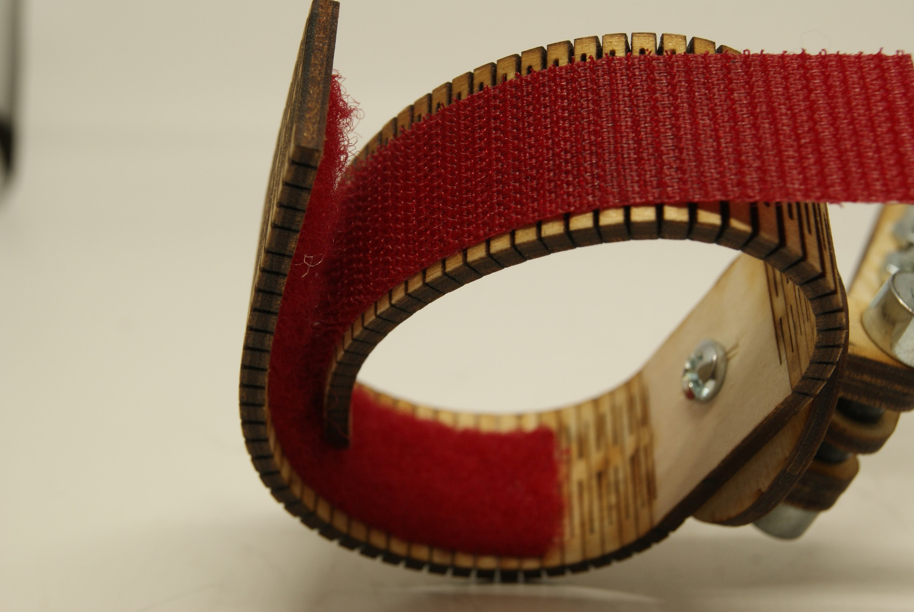 | Velcro Straps  The velcro straps allow for adaptability. Unlike belt holes or fixed flaps, Velcro gets the grip and universality required. Moreover, it’s very compatible with the laser-cut wood straps.

  - Manufacturing Techniques
Laser Cutting
Laser cutting models the simplest manufacturing: 2D manufacturing. It’s extremely efficient and simple: following the design specifications. Moreover the other materials we use (assorted machine screws & components, metal shafts, and Velcro) are all very common, available, easy-to-produce, and therefore inexpensive. This also corresponds with the requirement of an open-source development platform, in which users can easily create and build upon Digit. In this design, I use the VersaLASER® (VLS), produced by Universal Laser Systems. From personal experience, this is a very common laser cutter. Any laser cutter that is approved for sale should reasonably have the precision required for this project.
  - Design Proposal
Digit will comprise a majority of laser-cut mechanical components, combined with common machine materials and electrical components. Compared to the first iteration, this design fixes the previous issues.
- The overall design could be adapted and improved for the use of the head and the foot with the use of laser-cut straps and modular components
- The current prototype is a significant obstruction to certain activities, and is not ergonomically comfortable.
- The circuit with potentiometers is now robust, avoids signal interference.
- The current potentiometers are .50 USD each and are small enough
- The PSoC 5 has USB HID capabilities
- The majority of components are laser-cut
- The current straps are firm and adjustable.
- The modular sticks with the fixed holes allow for optimal mechanical precision
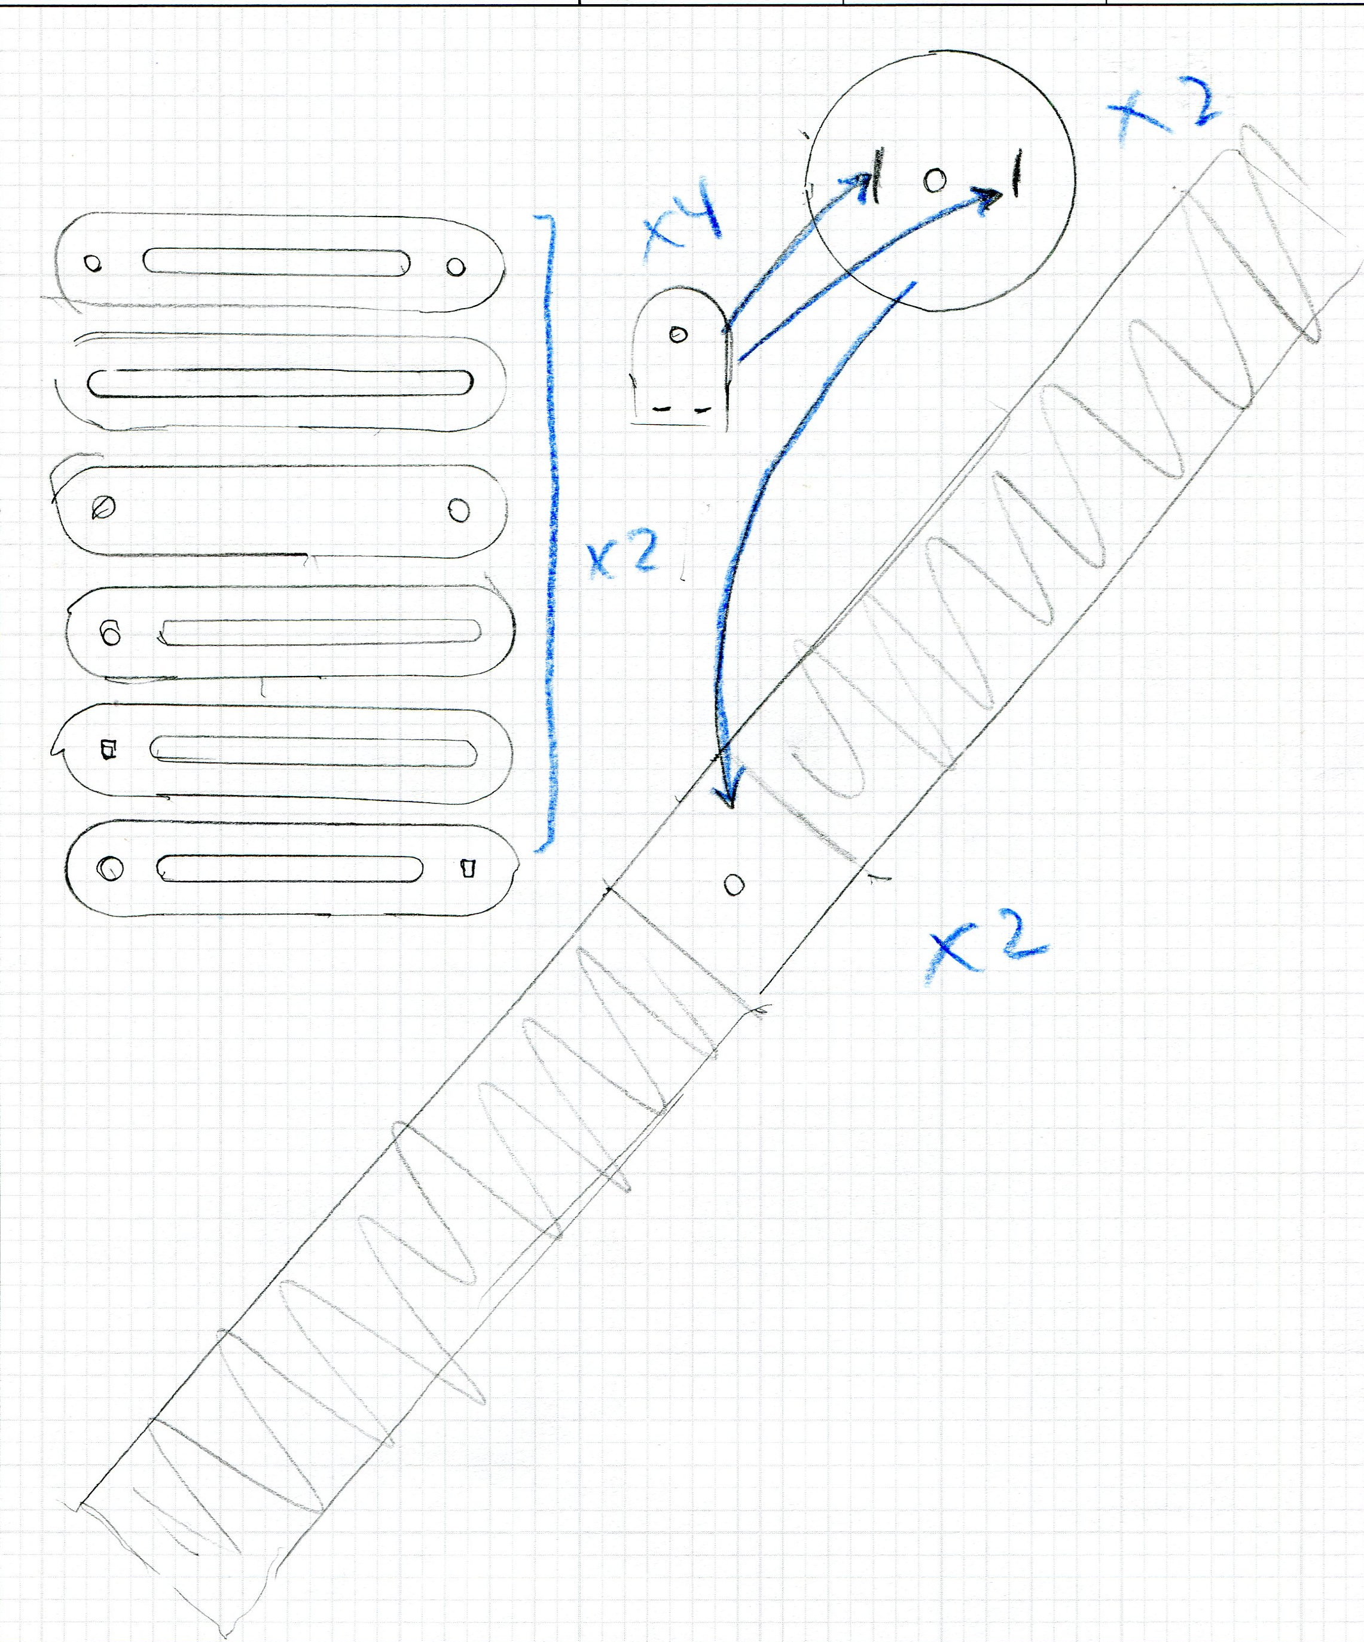
  - Manufacturing Plan
The below schematic is the scaled-down plan for the laser cutter
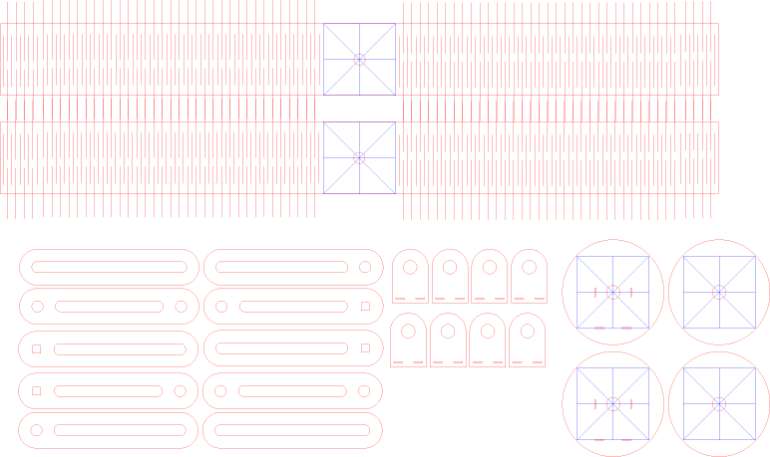
The below schematic represents each laser-cut component and its dimensions in inches.
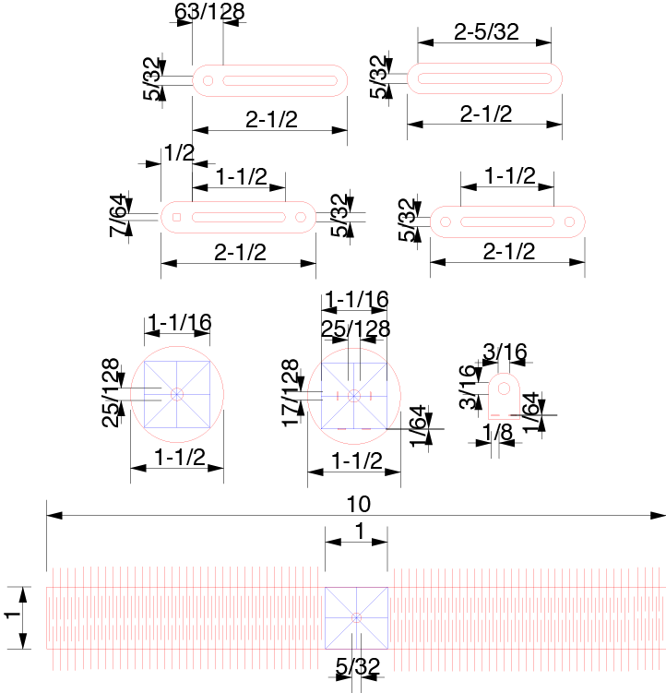
The steps for mechanical manufacturing are quite simple:
- Cut the components
- Glue together the ¼” stick-strap mount in pairs (preferably with wood glue)
- Glue the stick-strap mounts on the disk
- Attach the potentiometers to the respective stick-strap mounts and disks (fit w/ metal pins and glue to hold)
- Glue the x-axis potentiometer disk to a strap
- Screw together all the components using spacers for the base.
Electrical Components
I followed the default USB HID example for the PSoC 5 on the website to create my own HID. First the following layout must be copied in PSoC Creator.
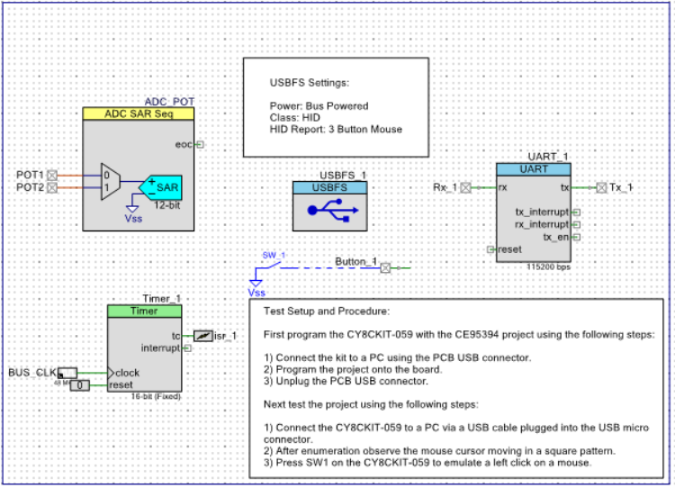
Then, after the program is cleaned and built, the following pins must be set:
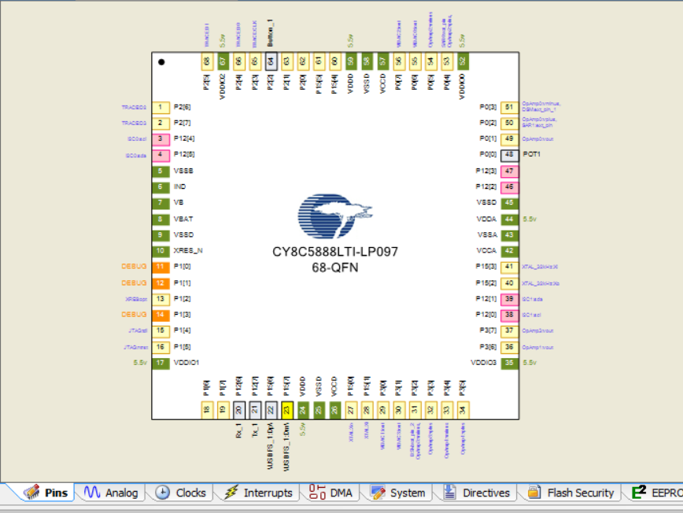
Then, the following C code must be implemented:
#include <device.h>

static int8 Mouse_Data[3] = {0, 0, 0}; /* [0] = Buttons, [1] = X-Axis, [2] = Y-Axis */
static uint16 Delay = 0;
void printInt(unsigned int n);

void main()
{
CYGlobalIntEnable; /* Enable Global Interrupts */
ADC_POT_Start();
ADC_POT_StartConvert();

int16 x = 0;
int16 y = 0;
USBFS_1_Start(0, USBFS_1_DWR_VDDD_OPERATION); /* Start USBFS Operation/device 0 and with 5V operation */
while(!USBFS_1_bGetConfiguration()); /* Wait for Device to enumerate */
USBFS_1_LoadInEP(1, (uint8 *)Mouse_Data, 3); /* Loads an inital value into EP1 and sends it out to the PC */

//start UART Host communication
UART_1_Start();

for(;;)
{
UART_1_PutChar('1');
while(!USBFS_1_bGetEPAckState(1)); /* Wait for ACK before loading data */
USBFS_1_LoadInEP(1, (uint8 *)Mouse_Data, 3); /* Load latest mouse data into EP1 and send to PC */

if(Button_1_Read() == 0) /* Check the button state and load the report with the curren status */
{
Mouse_Data[0] = 0x01; /* Report button 1 is pressed */
}
else
{
Mouse_Data[0] = 0x00; /* Report button 1 is not pressed */
}

// Delay++;

x = ADC_POT_GetResult16(0);
y = ADC_POT_GetResult16(1);

if (x < 0) x = 0;
if (y < 0) y = 0;

UART_1_PutString("x= ");
printInt((unsigned int) x);
UART_1_PutString(", y= ");
printInt((unsigned int) y);
UART_1_PutCRLF(' ');
//keeping y-axis static
Mouse_Data[2] = 0;
if (x < 1000) {
Mouse_Data[1] = 10;
}
else if (x > 1000 && x < 1500) {
Mouse_Data[1] = 5;
}
else if (x > 1500 && x < 2500) {
Mouse_Data[1] = 0;
}
else if (x > 2500 && x < 3000) {
Mouse_Data[1] = -5;
}
else if (x > 3000) {
Mouse_Data[1] = -10;
}

CyDelay(100);

}
}

void printIntInternal(unsigned int n) {
if (n != 0) {
//print all prior digits
printIntInternal(n/10);
//print last digit
UART_1_PutChar('0' + n%10);
}
}
void printInt(unsigned int n) {
// if the original print request is 0, honor it
if (n == 0) {
UART_1_PutChar('0');
}
else {
printIntInternal(n);
}
}
/* End of File */
With this program, the status of the device can also be read through the programmer via USB UART (Universal Asynchronous Receiver/ Transmitter)
The Final Product:
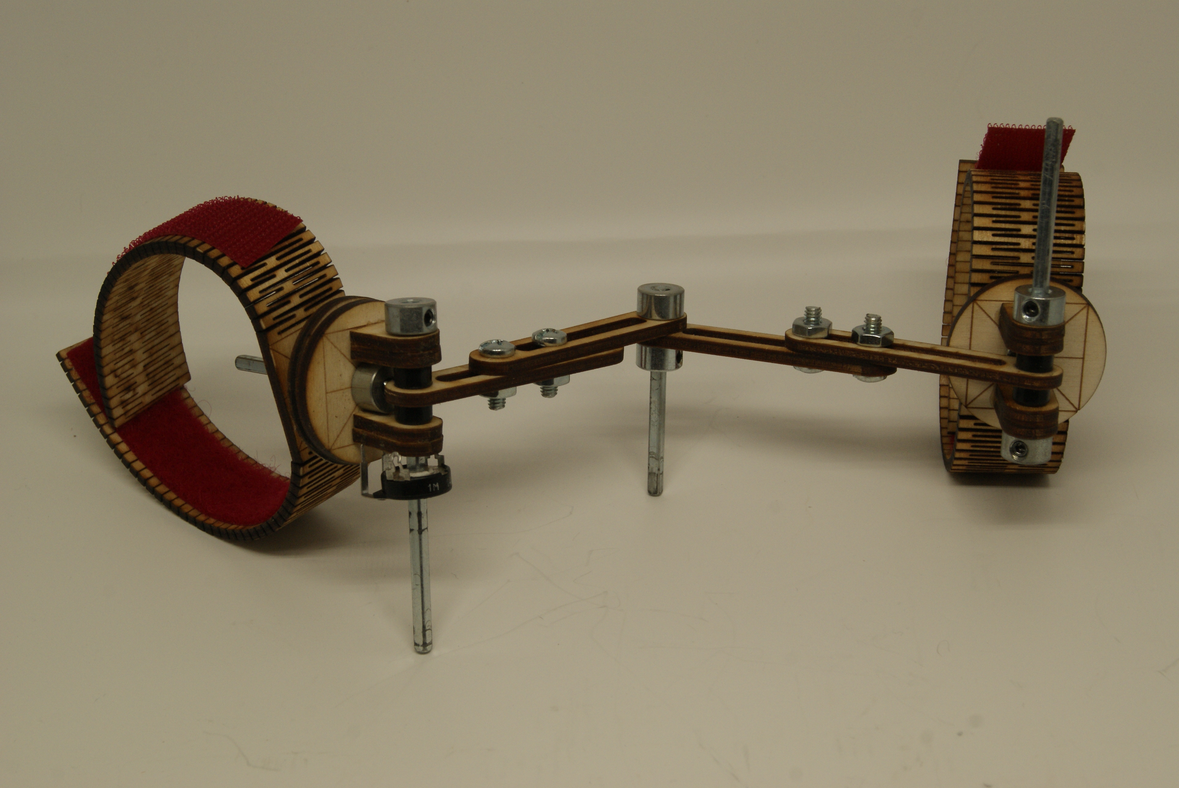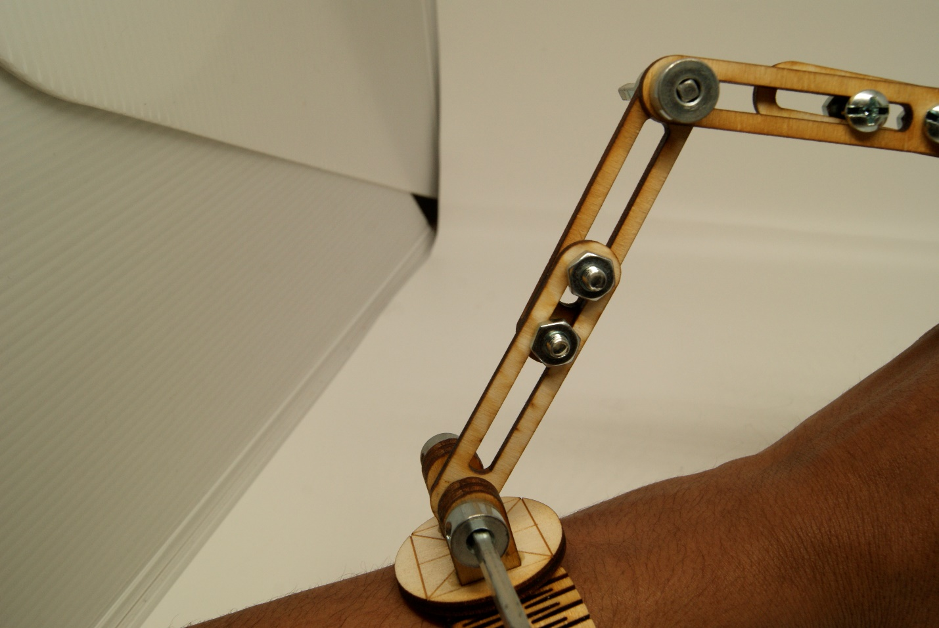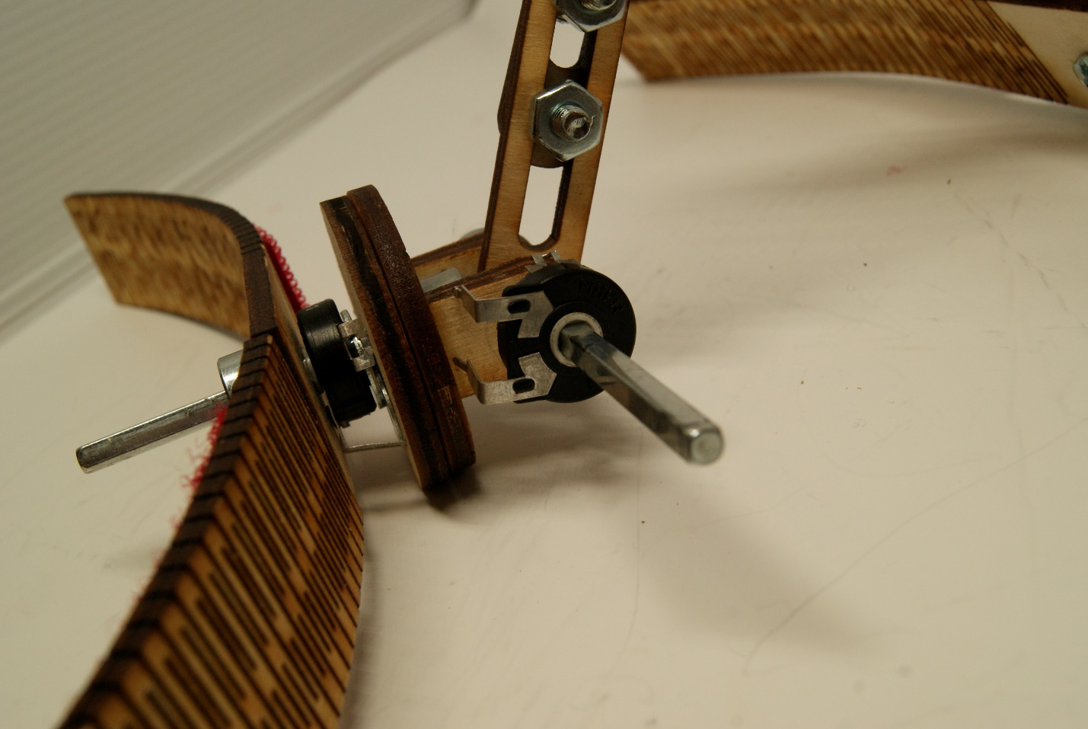
- Testing and Evaluation
  - Evaluation Against Design Specifications
- Cost efficiency
  - The HID is under 10 USD
- Functionality
  - The HID is able to control a mouse on a computer screen
- Universality
  - Modularity
    - The HID is modular so that the user, according to his/ her budget, can choose just the parts they require. Currently, Digit is simply the mechanical base design, and there aren’t any finalized additional parts. I’m currently developing an IMU that can be added for further precision.
  - Adaptability
    - The HID should be able to be used on nearly any part of the body, but given the time constraints, within two months, it should only be required to fit on the head, hand, and the foot. Currently, it can fit on the hand
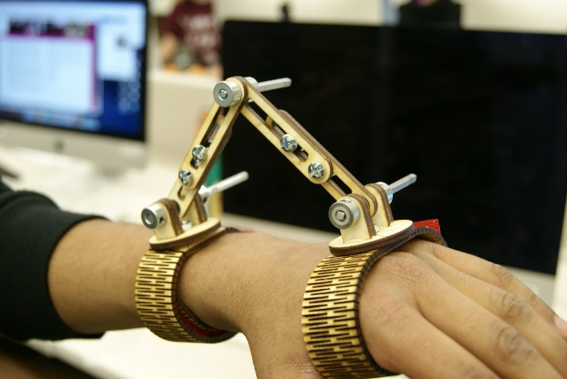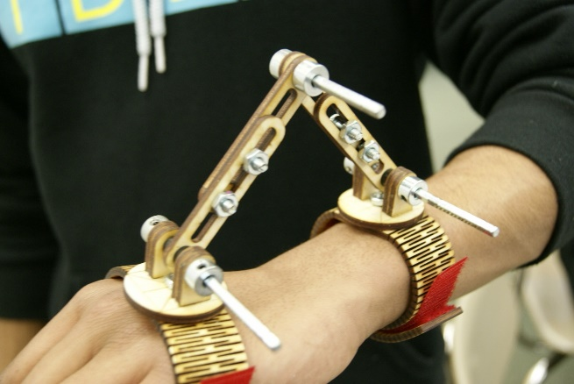
It shouldn’t be too difficult to fit this solution to the head and the foot, given that the straps can be extended to 24” (the max length of the laser cutter) and that the motions of pitch and yaw on the two sides of a joint (applicable to the head and food according to previous approximate ergonomic studies) can be measured using this device.
  - Ergonomics
    - The HID must be able to fit on any human with few exceptions. Within the two months, the device must be able to fit on humans who are not atrophied to the extent where a limb cannot be used or has become malformed. This has been accomplished.
- Further Development
  - Open Source Development Platform
    - Digit is simple enough so that it can serve as a platform for further development and applications that can be taken by the maker community. The laser-cut materials and simple components allow for the product to be easily reproduced and improved.
  - Evaluation Against Marketing Specifications
- Target Market
  - Involves the healthcare sector
    - Within the healthcare sector, the HID focuses on the assistive technology market
- Target Audience
  - Main Audience: ALS patients are targeted
  - Side Audiences:
    - ALS caregivers: it will be easier for the caregiver if they are able to receive further input, control, and independence from the patient
    - ALS Assistive Technology Providers: ATPs won’t have to customize expensive technologies for their patients.
    - ALS Assistive Technology Coordinators: The coordinators will have far less financial obstacles
    - All these side audiences are covered
- Market Research & Analysis
  - According to a report from BBC Research, the global market for assistive technologies is projected to reach 40.9 billion USD in 2016.
  - There is a market gap for cheap assistive technologies that have computer capabilities. Digit achieves this.
- User Need
  - The ALS patient needs a cheap human interface device that they would be able to use – to whatever functionality they require – without expensive customization from an assistive technology provider. Digit achieves this.
- Current Market Solutions & Competition
  - A six-axis head mouse would be able to achieve what is necessary for this design functionally, however, prices are in the hundreds of dollars.
  - Basic switches are low-functionality: they’re just buttons. However, they still are over-expensive in the range of 50 – 100 USD.
  - There is no market solution for assistive technology that is under 10 USD AND can control a computer. Digit achieves this.

  - Improvements/ Next Steps
Expansion Applications
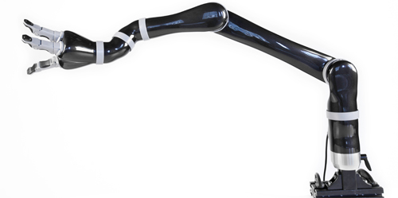
This is simply an input device. The applications of this device in the healthcare industry are numerous, ranging from existing common assistive technologies such as wheelchairs & robotic arms to future applications such as deriving a muscle degradation index. Wheelchairs and robotic arms have a common input mechanism. This mechanism is utilized by the JACO Robotic Arm by Kinova Robotics (pictured above). I tried out this robotic arm during a presentation at Dependable Medical Equipment recently; it shouldn’t be too difficult to adapt the signals from Digit to fit that of the common assistive technology input reception device.
Modular Additions
For specific applications that require more precision, such as deriving a muscle degradation metric from passively monitoring movement, Digit may need a modular 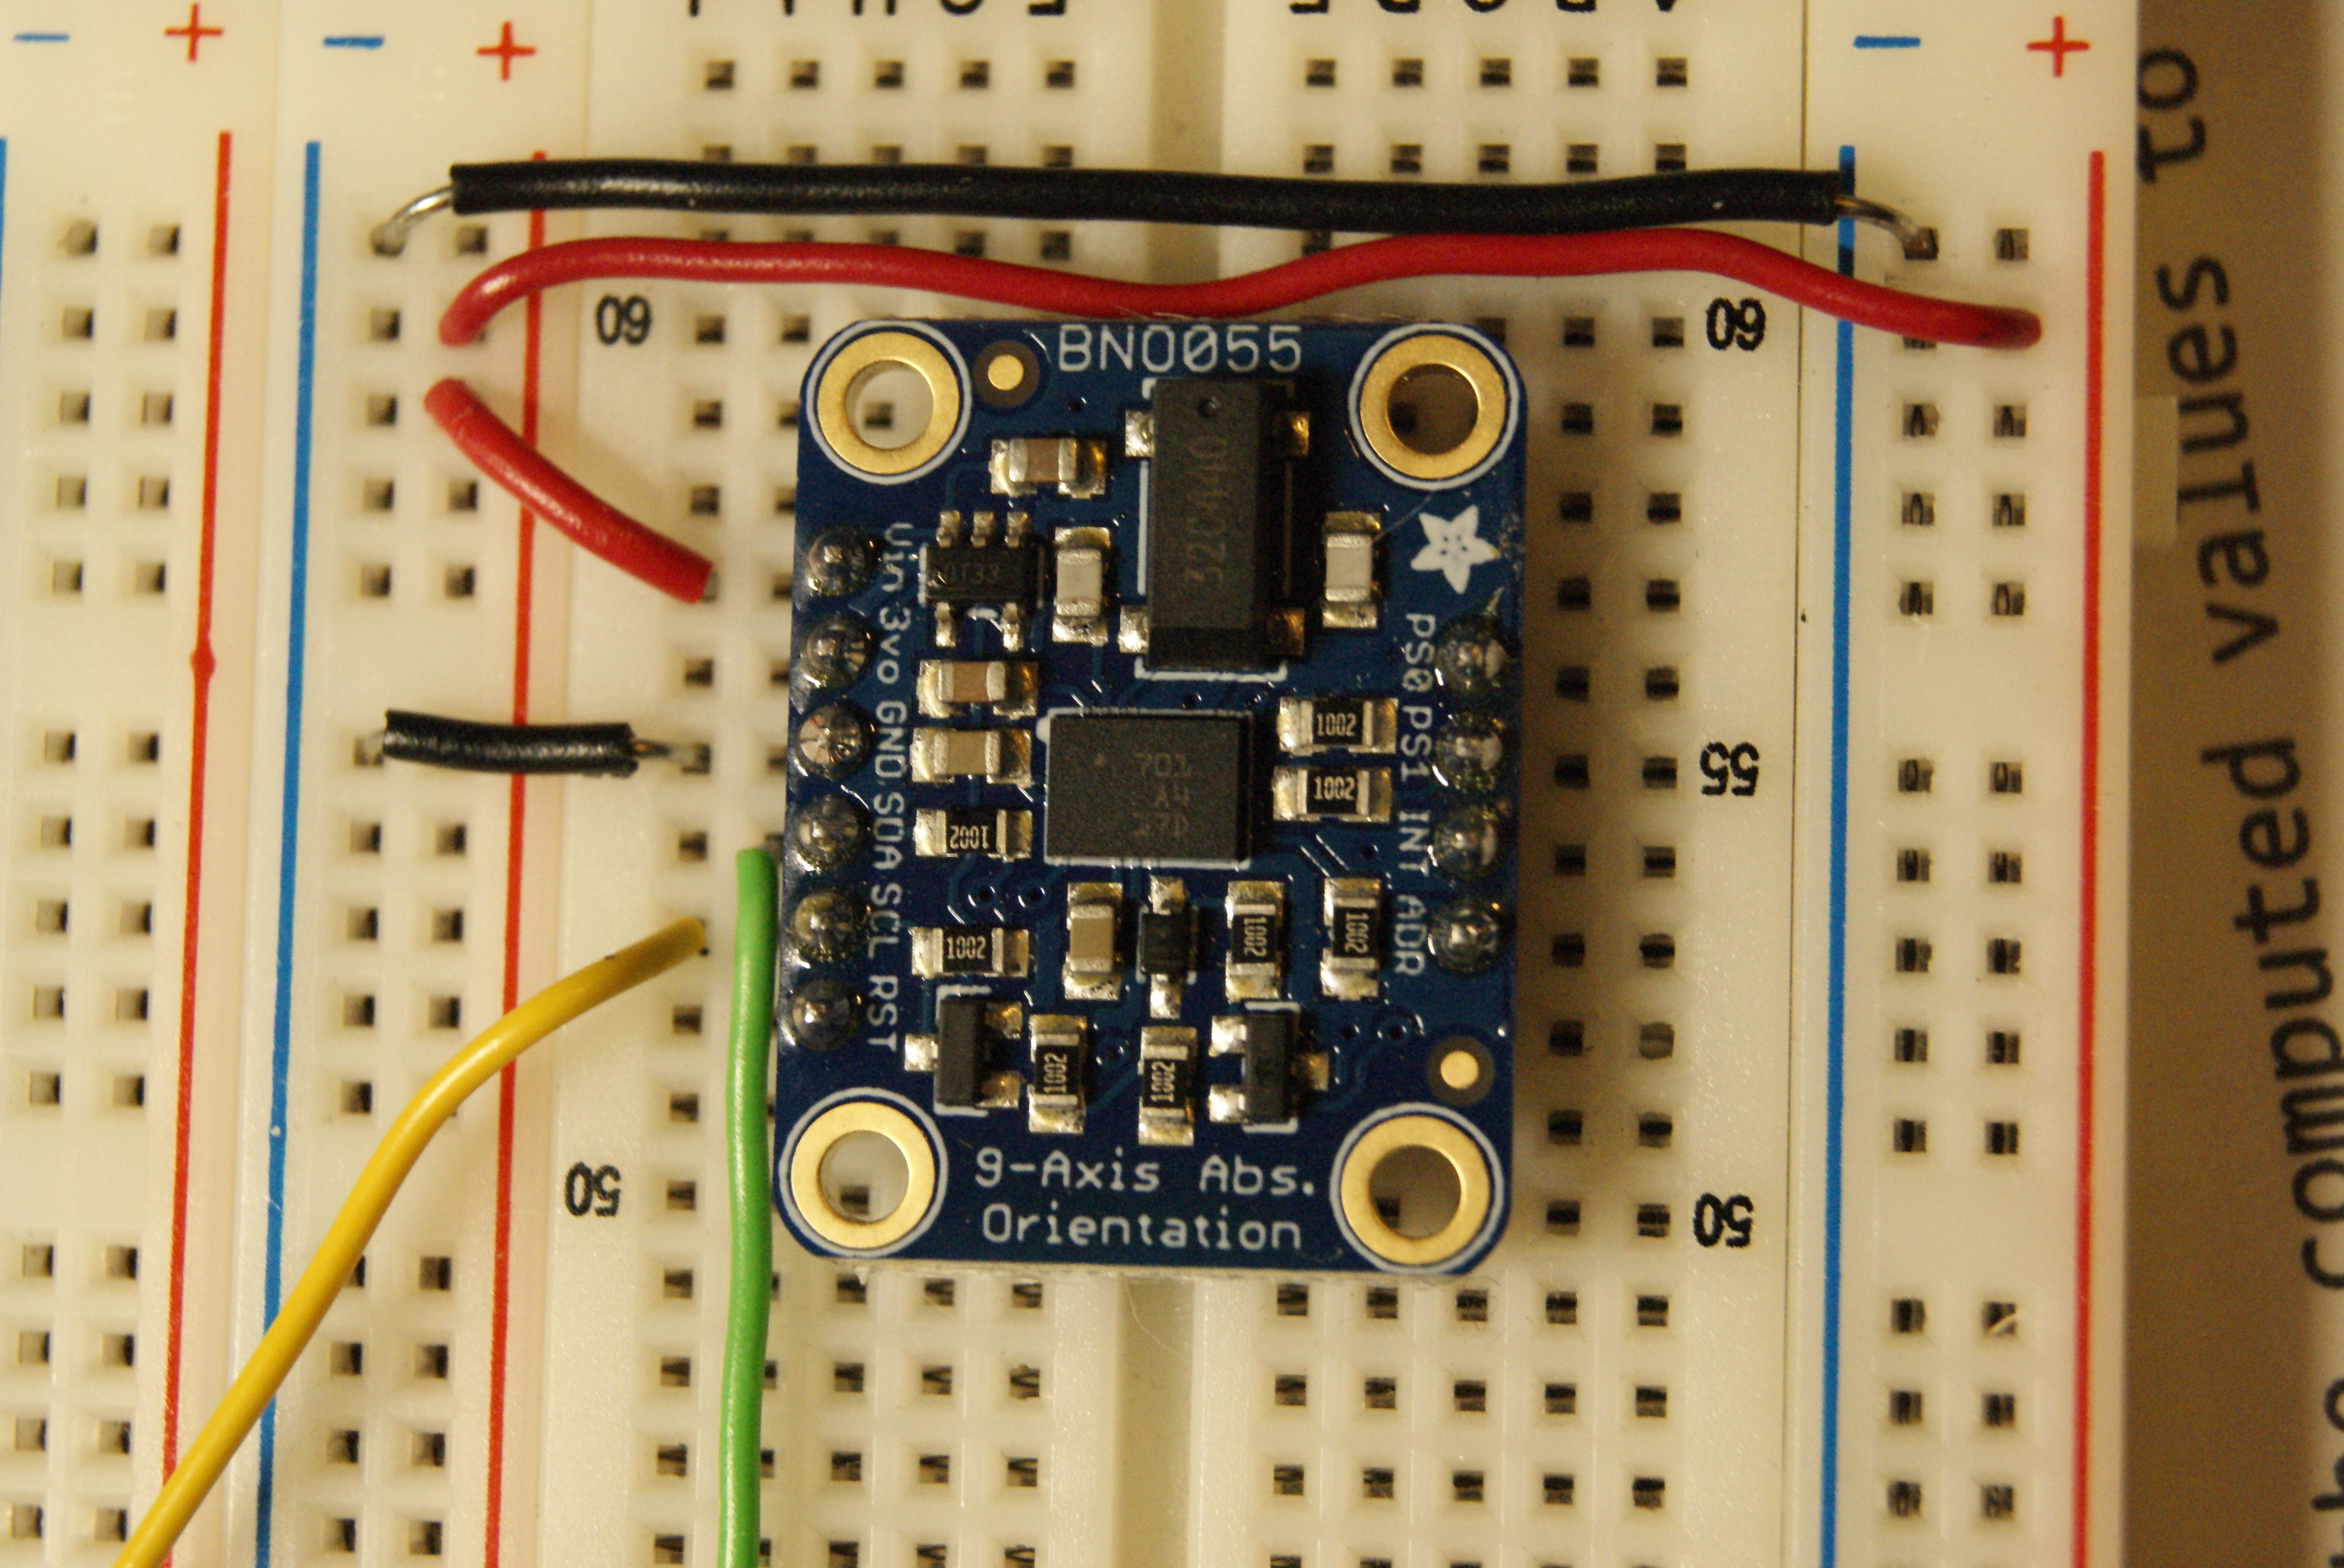upgrade. This can be achieved by attaching higher-cost and higher-functionality components such as Inertial Measurement Units. I’ve already began integrating IMUs into the design using the BNO055 9DOF (Degree-of-Freedom) sensor from Adafruit. It’s approximately $35, but the individual components of this chip can be produced to use only the components required.

Further Future Directions
- Automated adaptability: Digit collects data that would allow it to adapt to user inputs over time, interpreting whether the location of Digit’s components should be moved
- Increased functionality: we could use multiple modes (to allow for more than simply 2-D motion)
- The motion tracking could allow for a speech mode in which users can record motions to indicate letters then recreate those motions to speak through a speech-generation devices, a method far more effective than the traditionally used eye-tracking keyboard
- Modularity of analysis: allowing variable analysis functions depending on the level of progression of the patient would be highly beneficial and possible with the data collected
Works Cited
"32-bit ARM® Cortex®-M3 PSoC® 5LP." Cypress. Cypress Semiconductor, n.d. Web. 11 Mar. 2016. <http://www.cypress.com/products/32-bit-arm-cortex-m3-psoc-5lp>.
Forshew, Dallas, et al. Living with ALS. Comp. Mary Lyon. Illus. Denton Design Associates and Neverne Covington. 6 vols. N.p.: ALS Association, 2007. Print.
Gaddis, Jacqueline. E-mail interview by Anand Sekar. 16 Feb. 2016.
- - -. Telephone interview by Anand Sekar. 13 Feb. 2016. Jacqueline Gaddis is a versatile individual providing comprehensive assistive technology services as it relates to augmentative and alternative communication and access to other technology. Works with the ALS Association Evergreen Chapter's Care Services staff to provide technological support to families living with ALS throughout the service area: Washington, Idaho, Alaska and Montana.
Gaddis, Jacqueline, and Nathaniel Swenson. Interview by Anand Sekar. 17 Feb. 2016. This interview took place at Bailey Boushay House, an assisted living facility, during an assistive-technology focused ALS support group meeting. Both Jacqueline Gaddis and Nathaniel Swenson were there, along with others who had or were affected by ALS. I was able to gather needed user input.
Rohrer, Brandon, and Susan Fasoli. "Movement Smoothness Changes during Stroke Recovery." JNeurosci. Society for Neuroscience, 15 Sept. 2002. Web. 11 Mar. 2016. <http://www.jneurosci.org/content/22/18/8297.long>.
Swenson, Nathaniel. Personal interview. 1 Feb. 2016. Nathaniel Swenson is an assistive technology practitioner at Dependable Medical Equipment. He specializes in designing custom seating for complex rehab equipment, and working as part of a rehab team with patients and their therapists to develop custom wheelchairs that optimize comfort and independent mobility.

